What is the difference between set and group in tableau?

Grouping in Tableau is grouping multiple members in a **SINGLE** dimension into a higher category and creating a set is grouping members from **MULTI** dimensions and/or condition into a dynamic or constant group. So, sets are just a more complex and dynamic grouping.

Example- set of top 10 customers with highest sales

PARAMTER: A Parameter is any value passed to a program in order to customize the program for a particular purpose. A parameter could be anything: A string of text, a range of values, or an amount just to name a few.  In Tableau, think about it like this; you need to have something for your visualization that is not exactly in your data.  A parameter will allow you to provide a value to pass into Tableau. Parameters allow you to come up with scenarios or options that are not available in your data and create these values to put into your visualization. After creation, end users can control the input to see the results of the parameters effect.

**Four Key Things That Must Be in Place for Parameters:**

**1. Create the Parameter**

**2. Use the Parameter in a Calculation**

**3. Show the Parameter Control for the User**

**4. Use the Calculated Field in Your Visualization**

**Source: SuperstoreUSA**

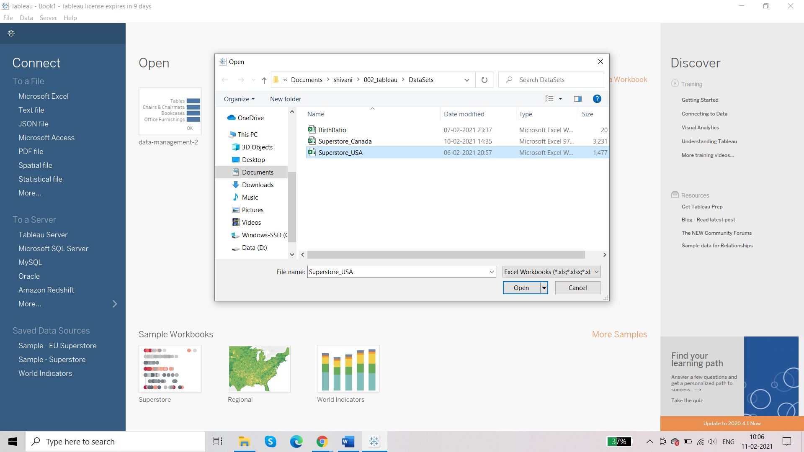

Sheet 1:

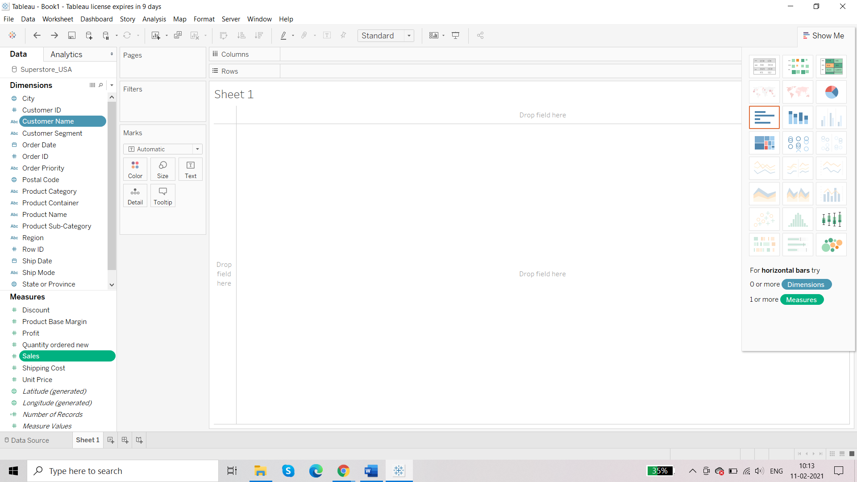

**Requirement: create set for top 10 customers in terms of sales**

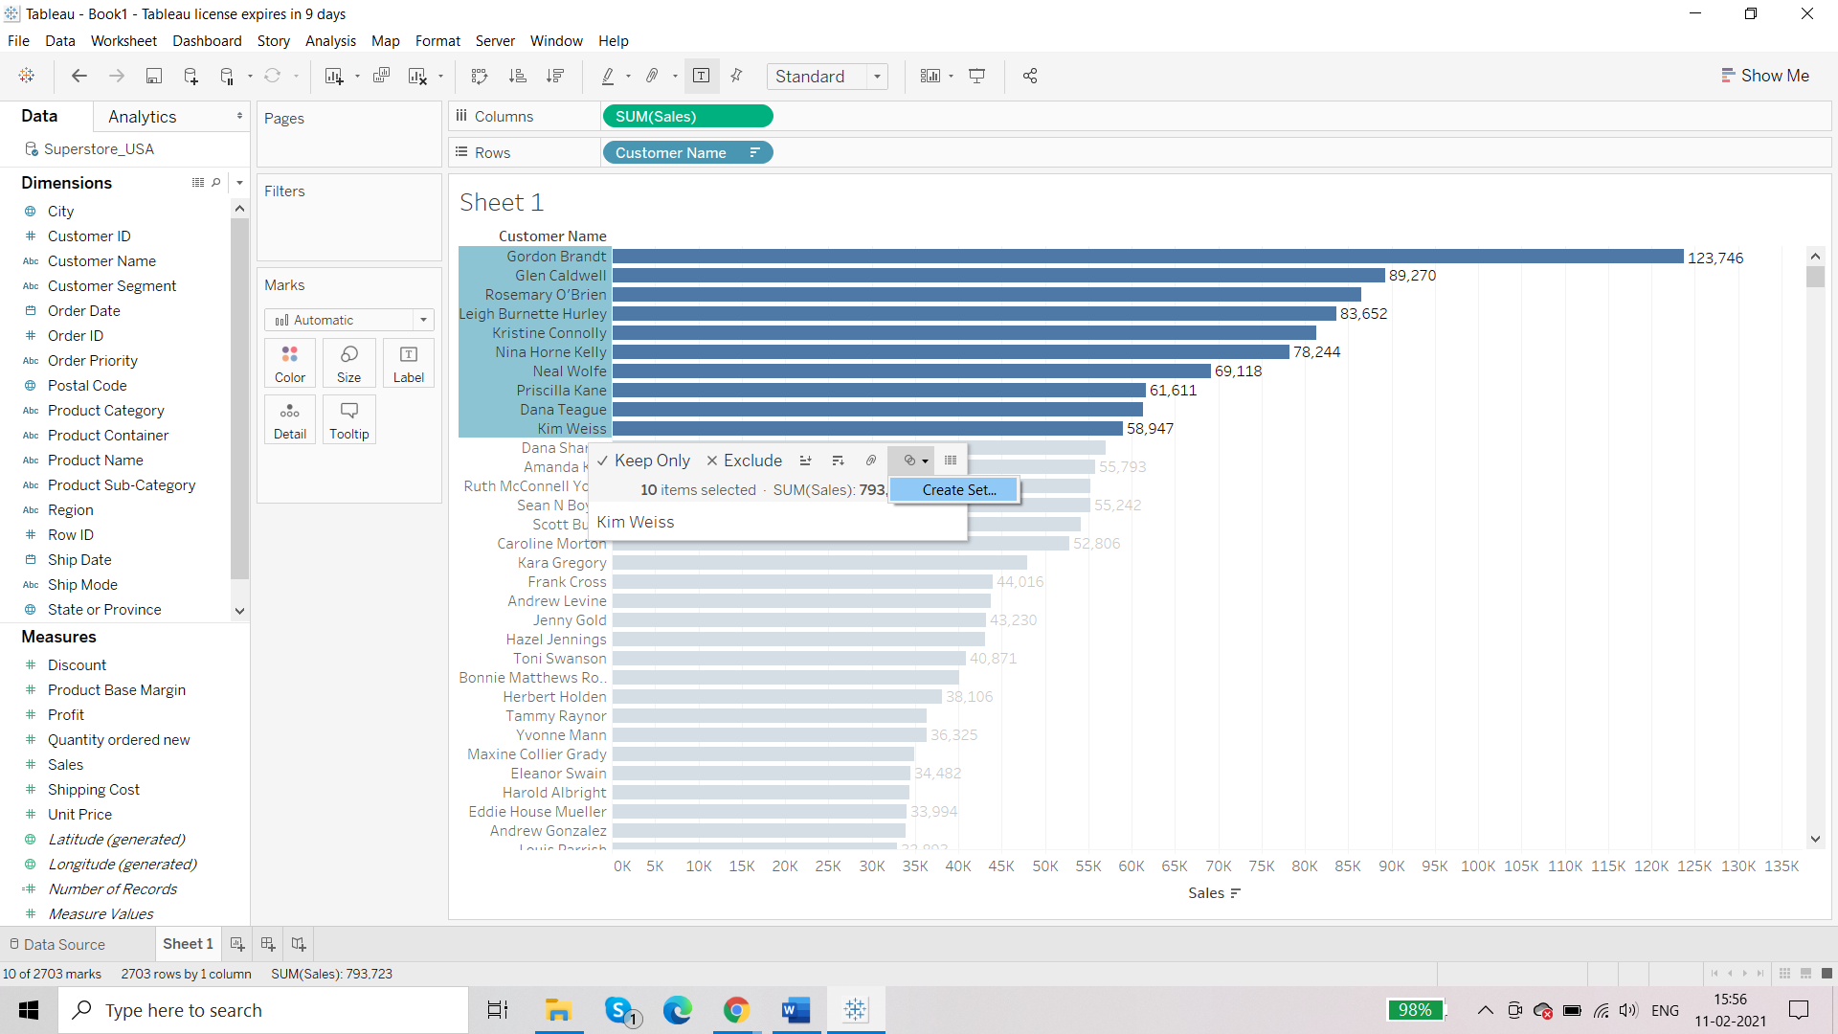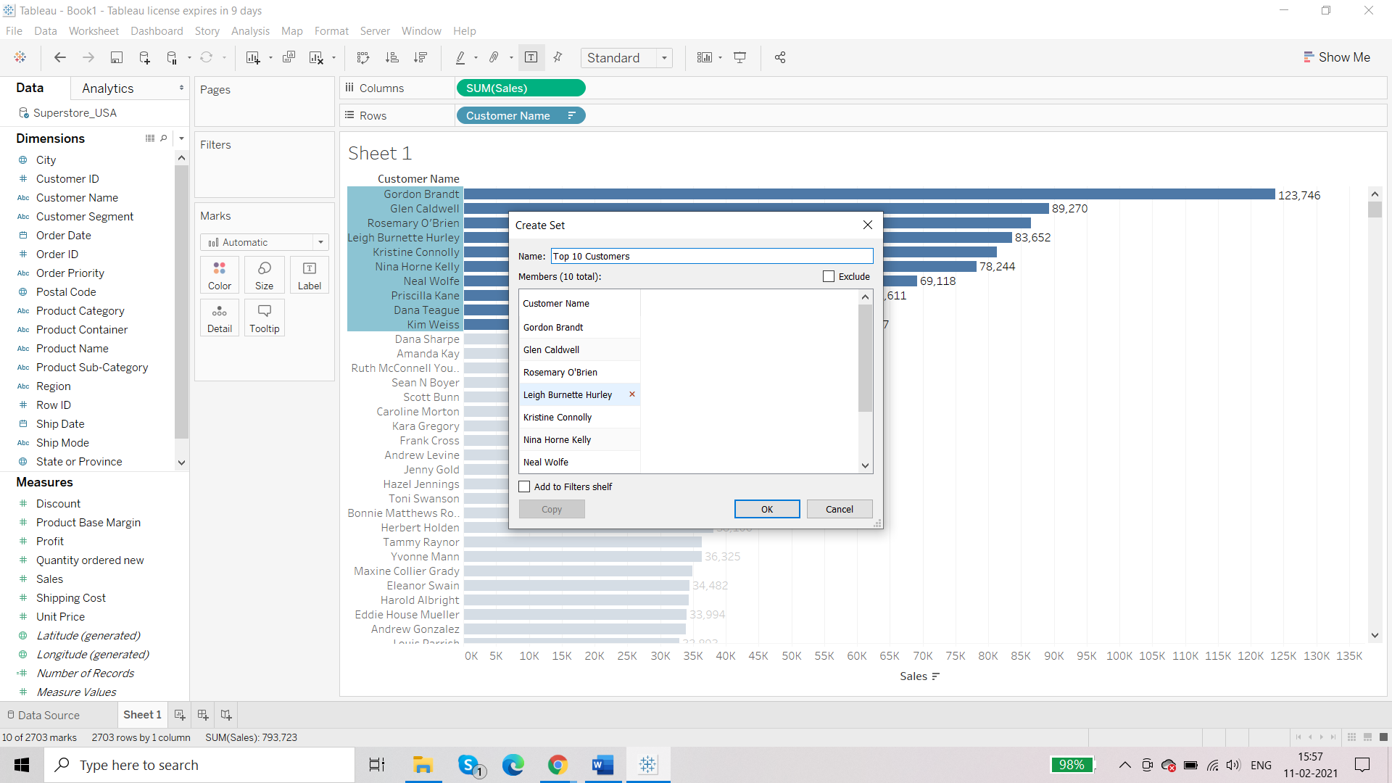

You will notice that there is separate card for sets in the bottom after measures in the bottom left:

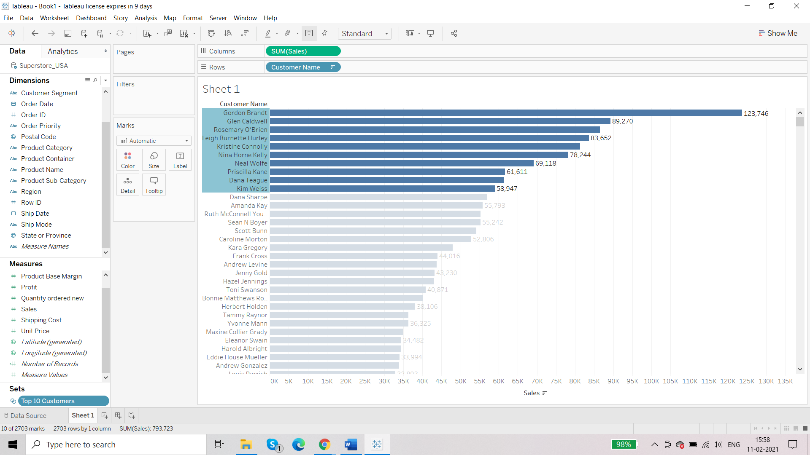

For every set, there is IN and OUT property:

Remove ‘Customer Name’ from rows shelf and add the set ‘Top 10 Customers’:

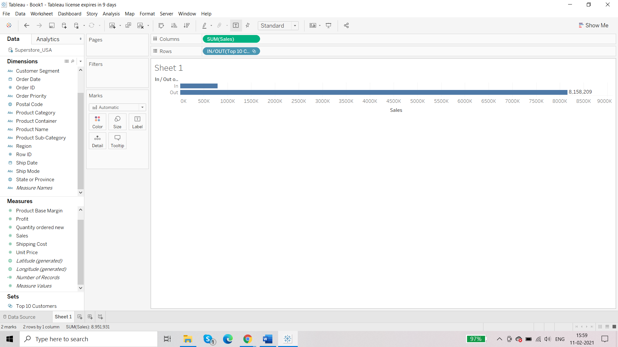

IN: all those data members that are a part of the set

OUT: all those data members that are not the part of the set

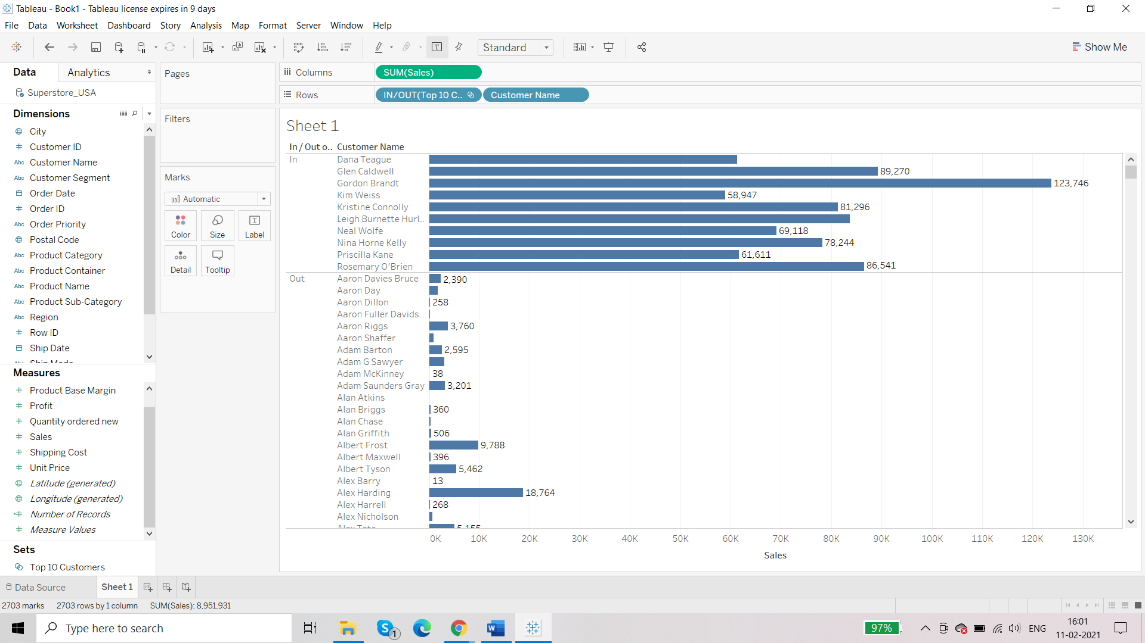

You can remove the customers who are not the part of the set:

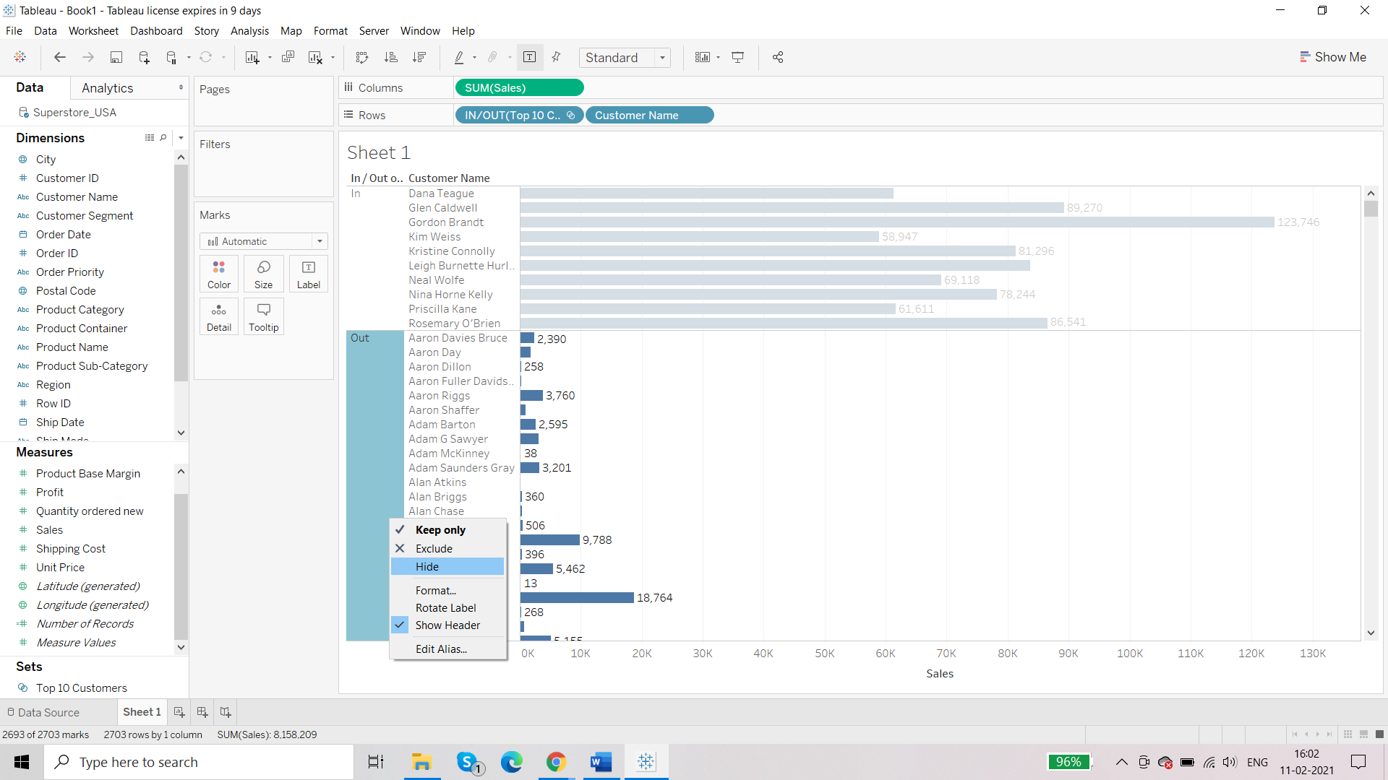

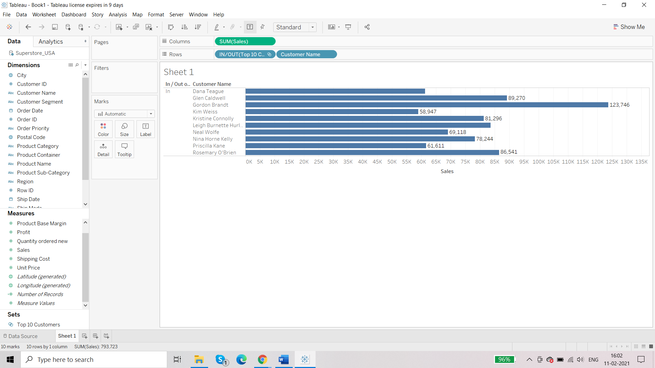

Give alias to IN

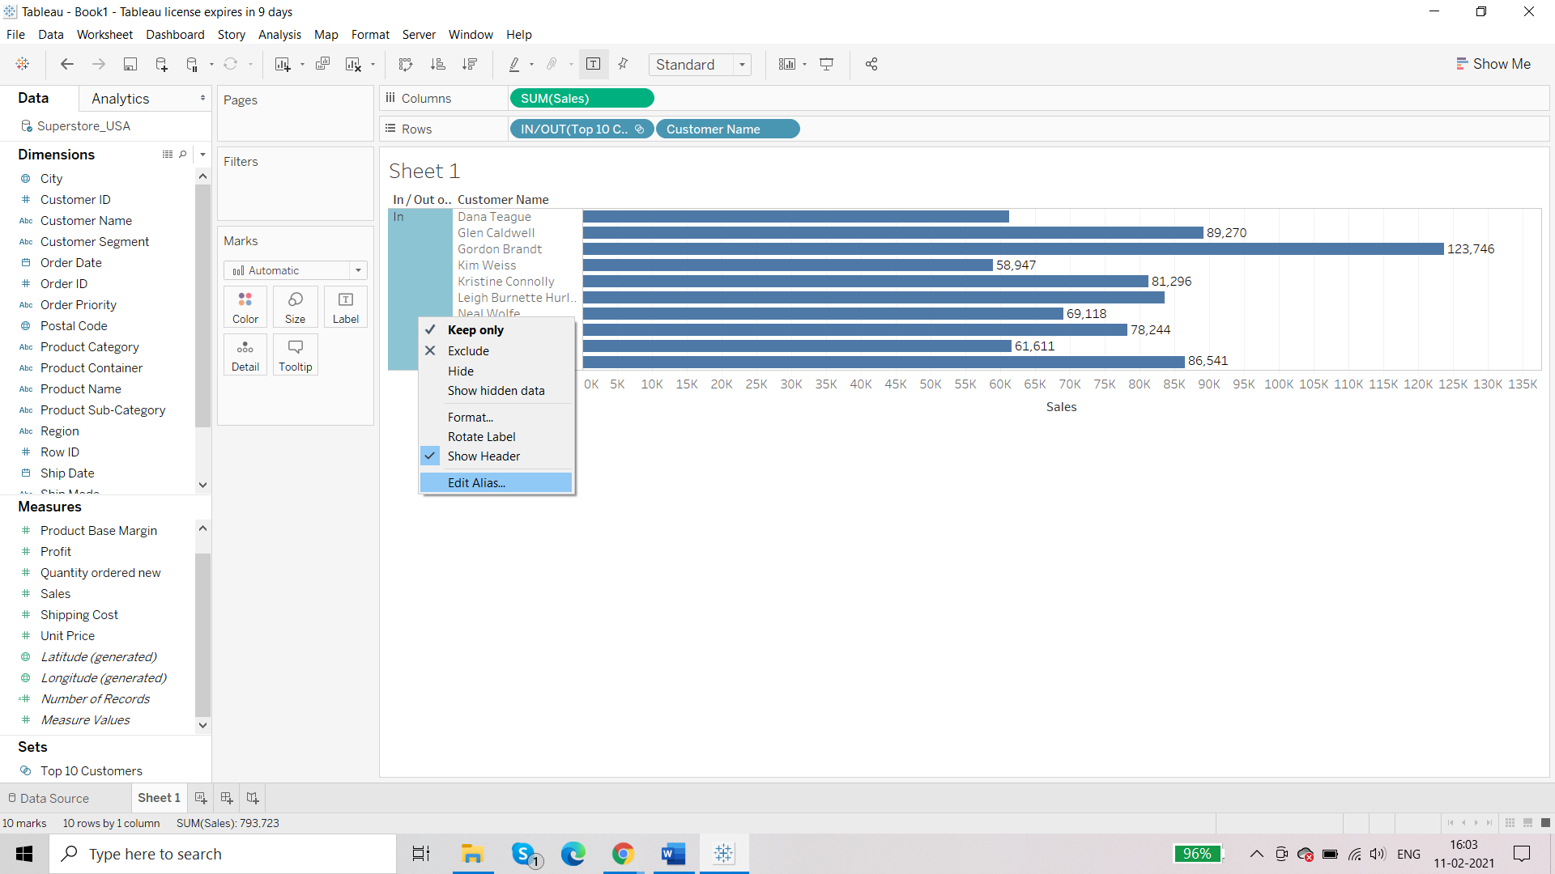

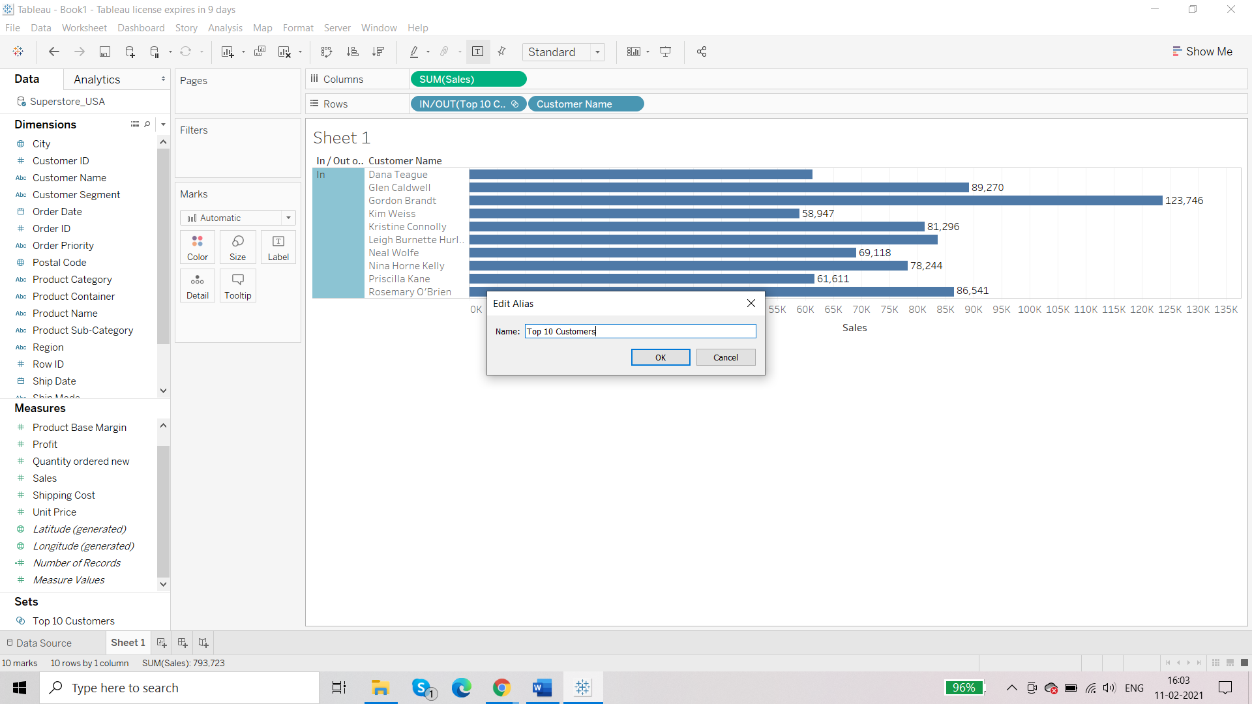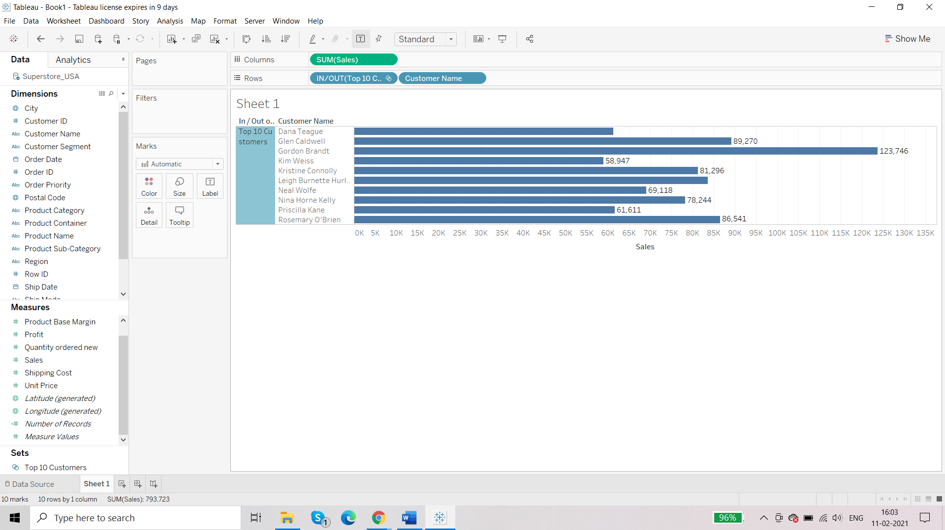

**Requirement: set – top 10 customers in terms of profit**

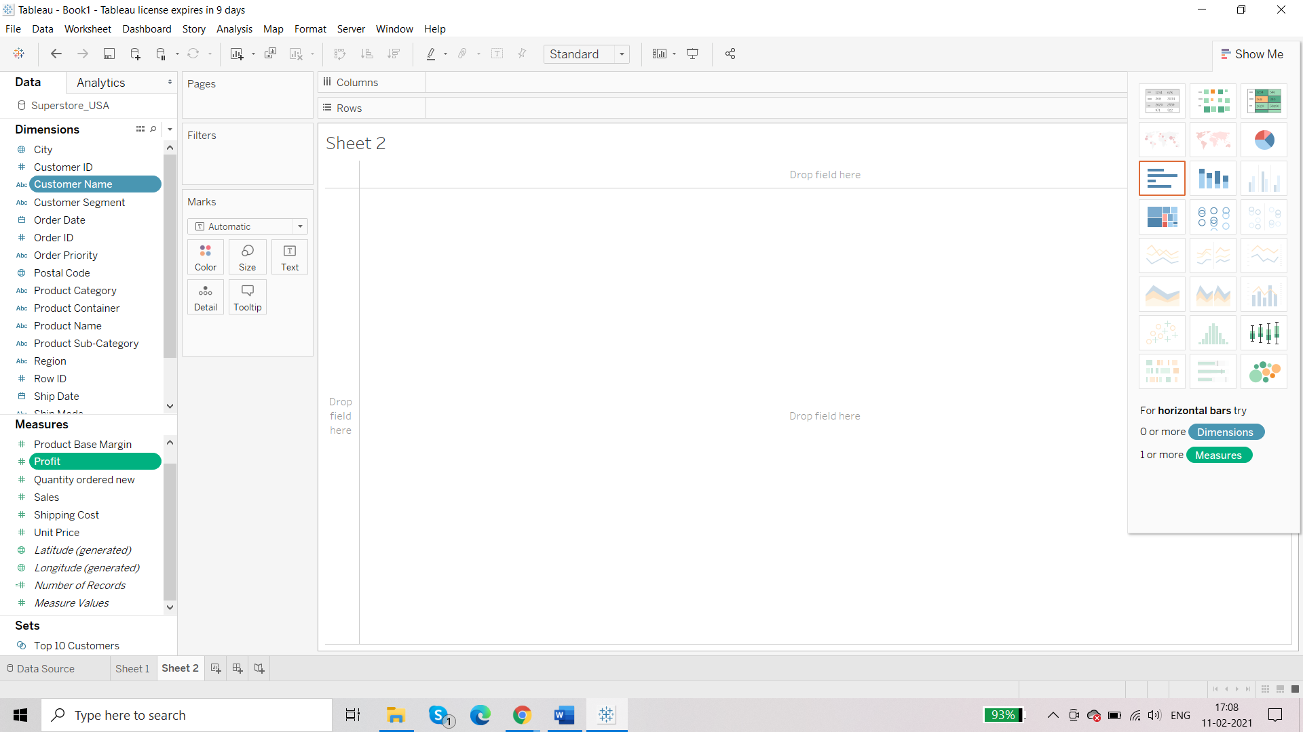

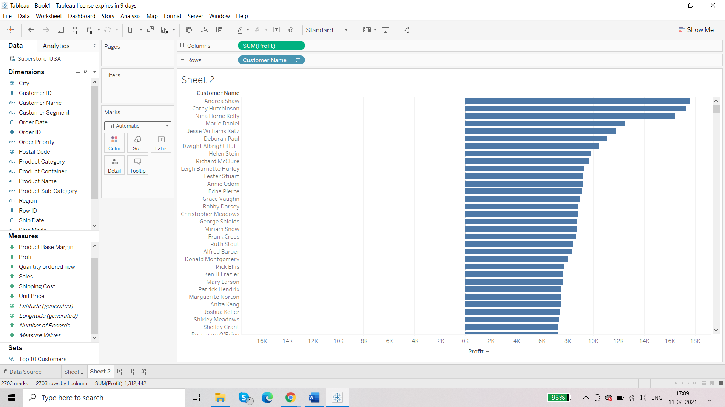

This gap is due to the negative profit.

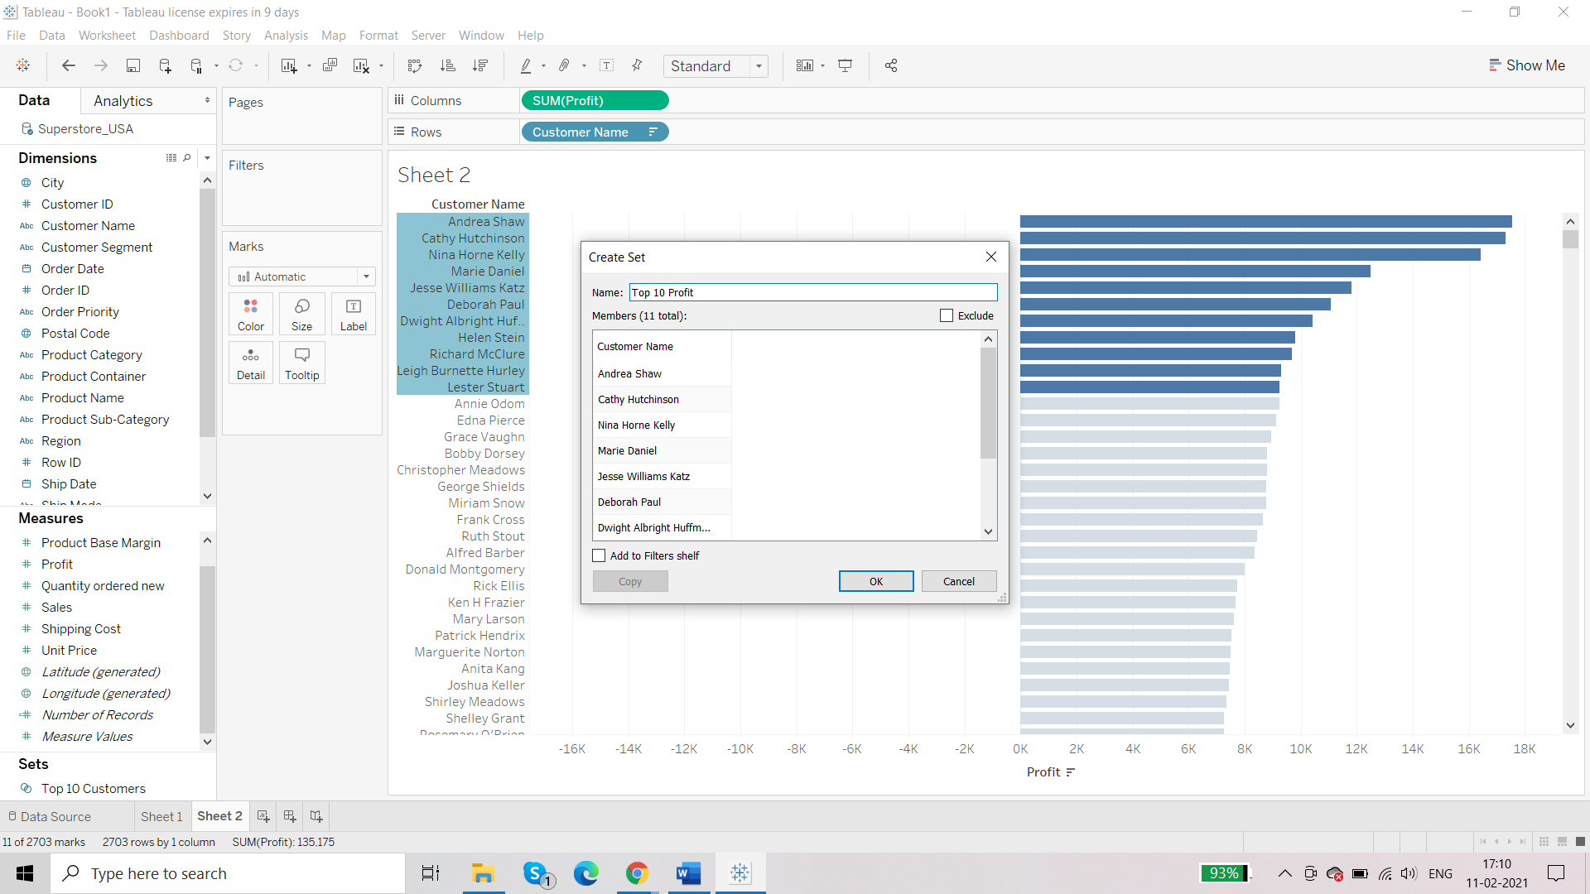

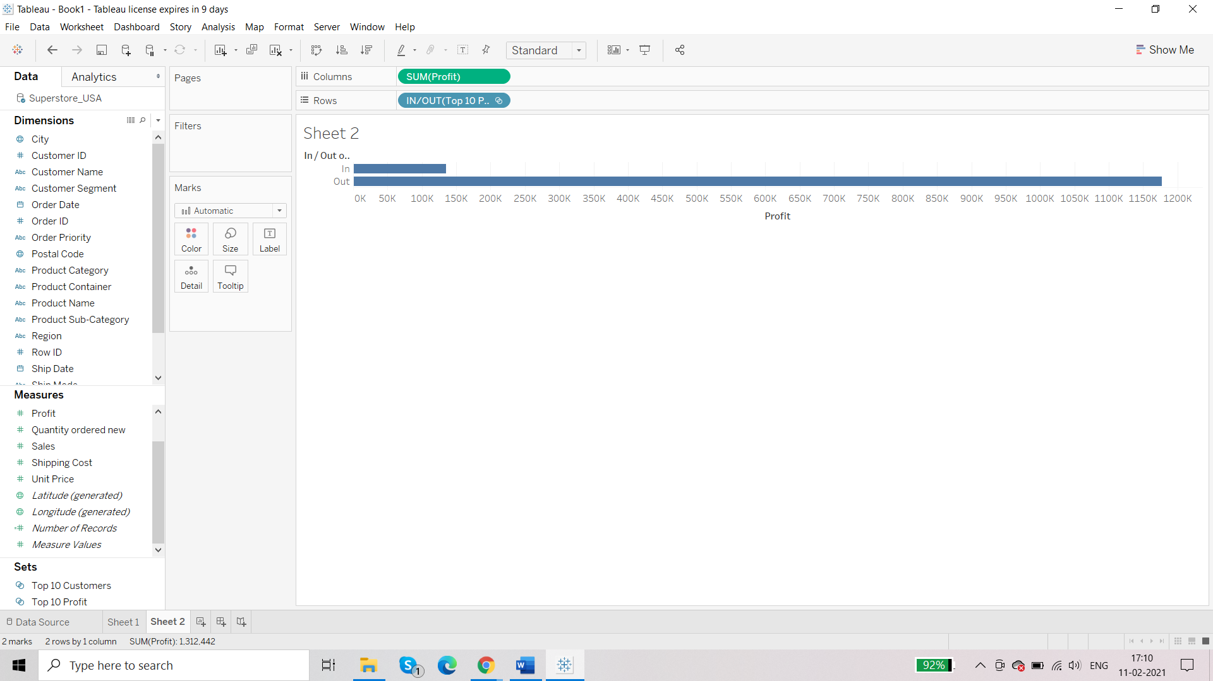

**Requirement: we want to find customers who have given top profit as well as top sales**

For this we can combine the existing two sets:

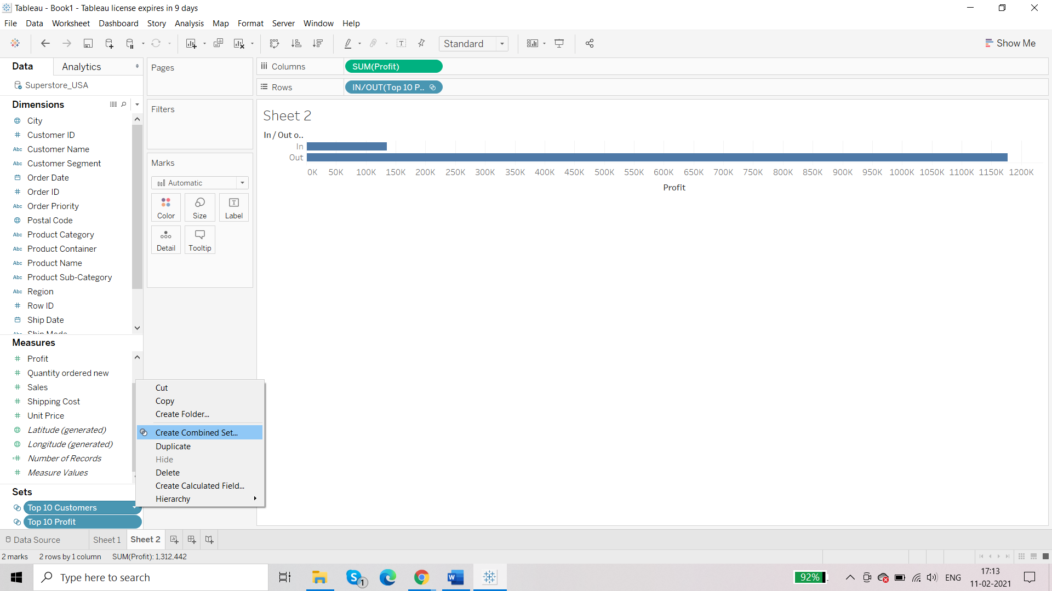

* Type a name for the new combined set.
* Verify that the two sets you want to combine are selected in the two drop-down menus.
* Select one of the following options for how to combine the sets:
  + **All Members in Both Sets** - the combined set will contain all of the members from both sets.
  + **Shared Members in Both Sets** - the combined set will only contain members that exist in both sets.
  + **Except Shared Members** - the combined set will contain all members from the specified set that don't exist in the second set. These options are equivalent to subtracting one set from another. For example, if the first set contains Apples, Oranges, and Pears and the second set contains Pears and Nuts; combining the first set except the shared members would contain just Apples and Oranges. Pears is removed because it exists in the second set.
* Optionally specify a character that will separate the members if the sets represent multiple dimensions.

Here we want second option:

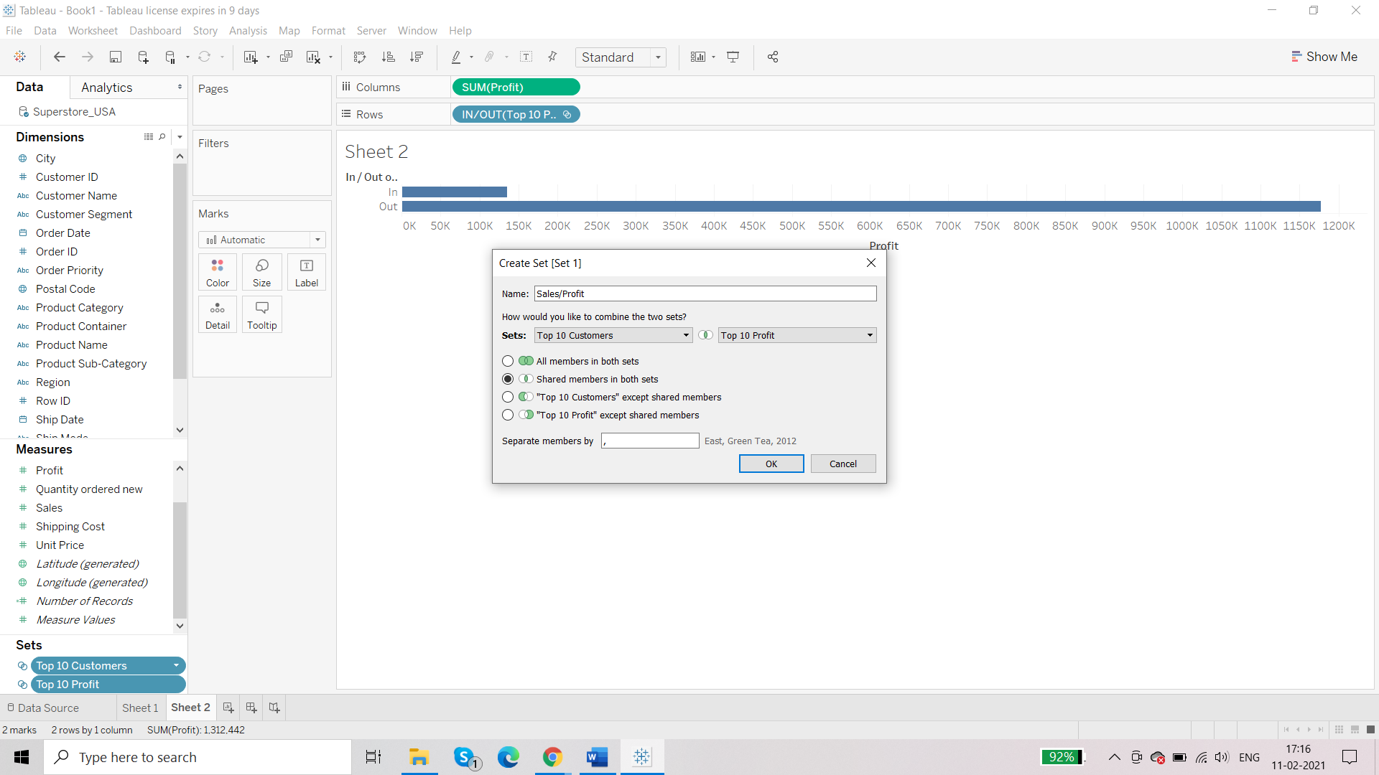

Plotting Sales/Profit:

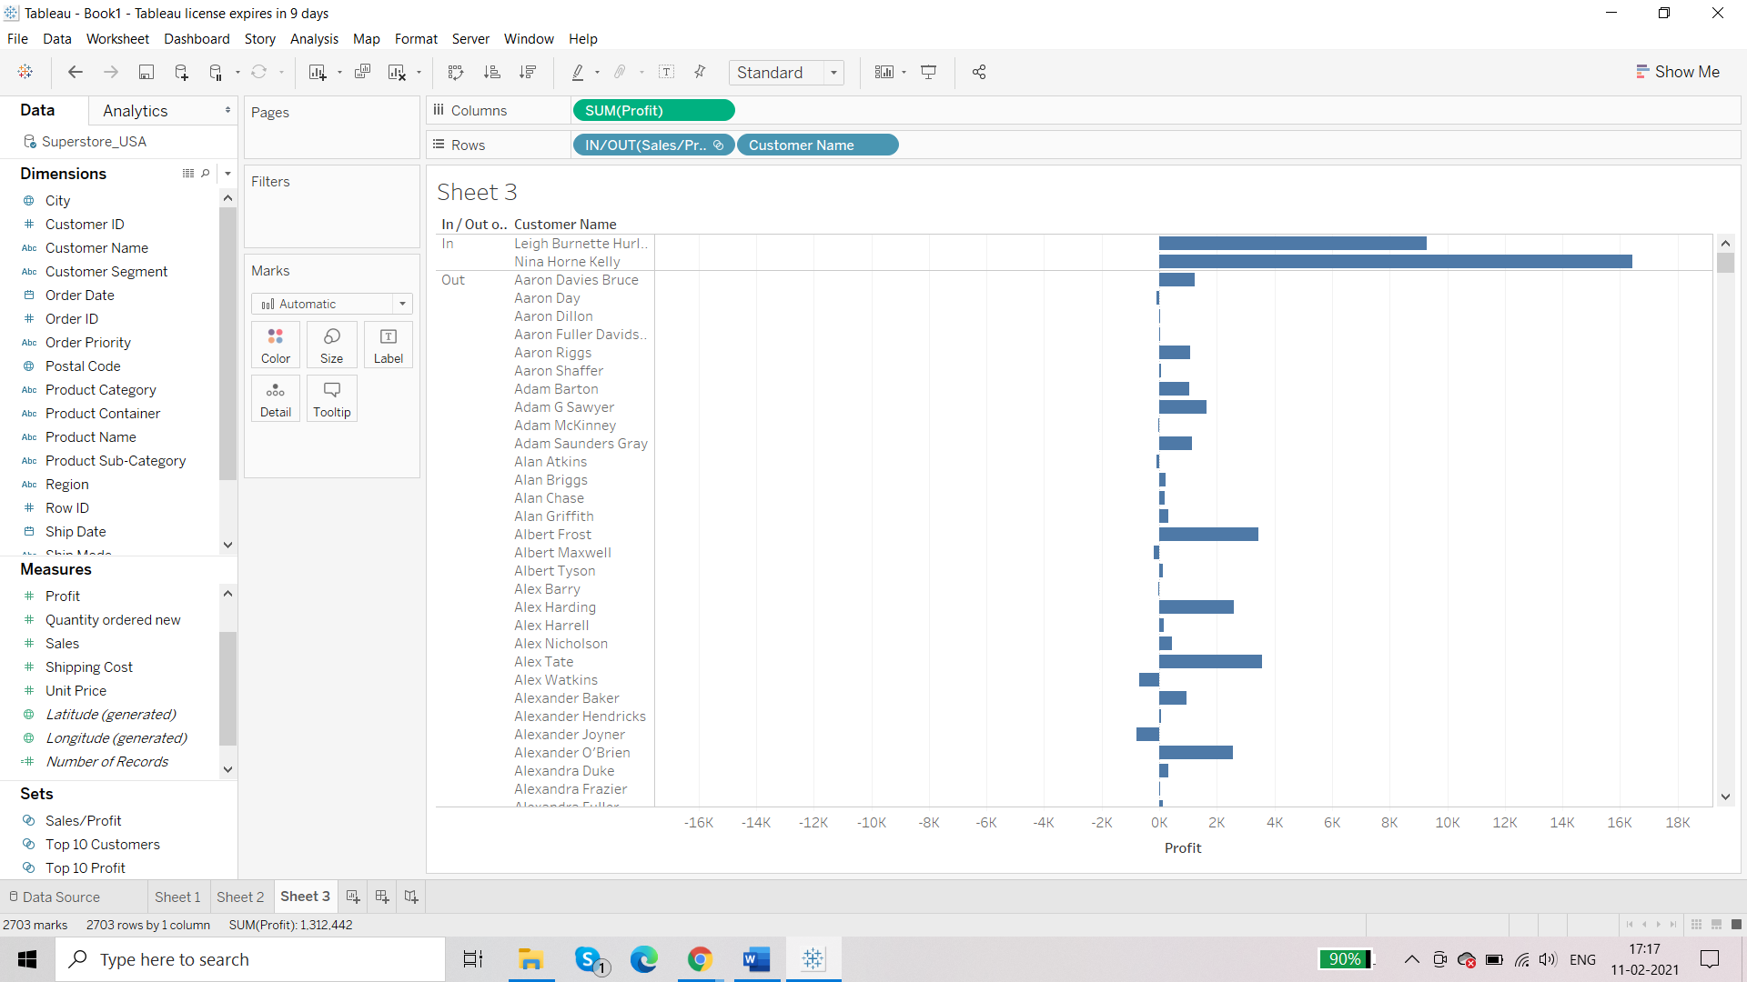

Hide the ‘Out’

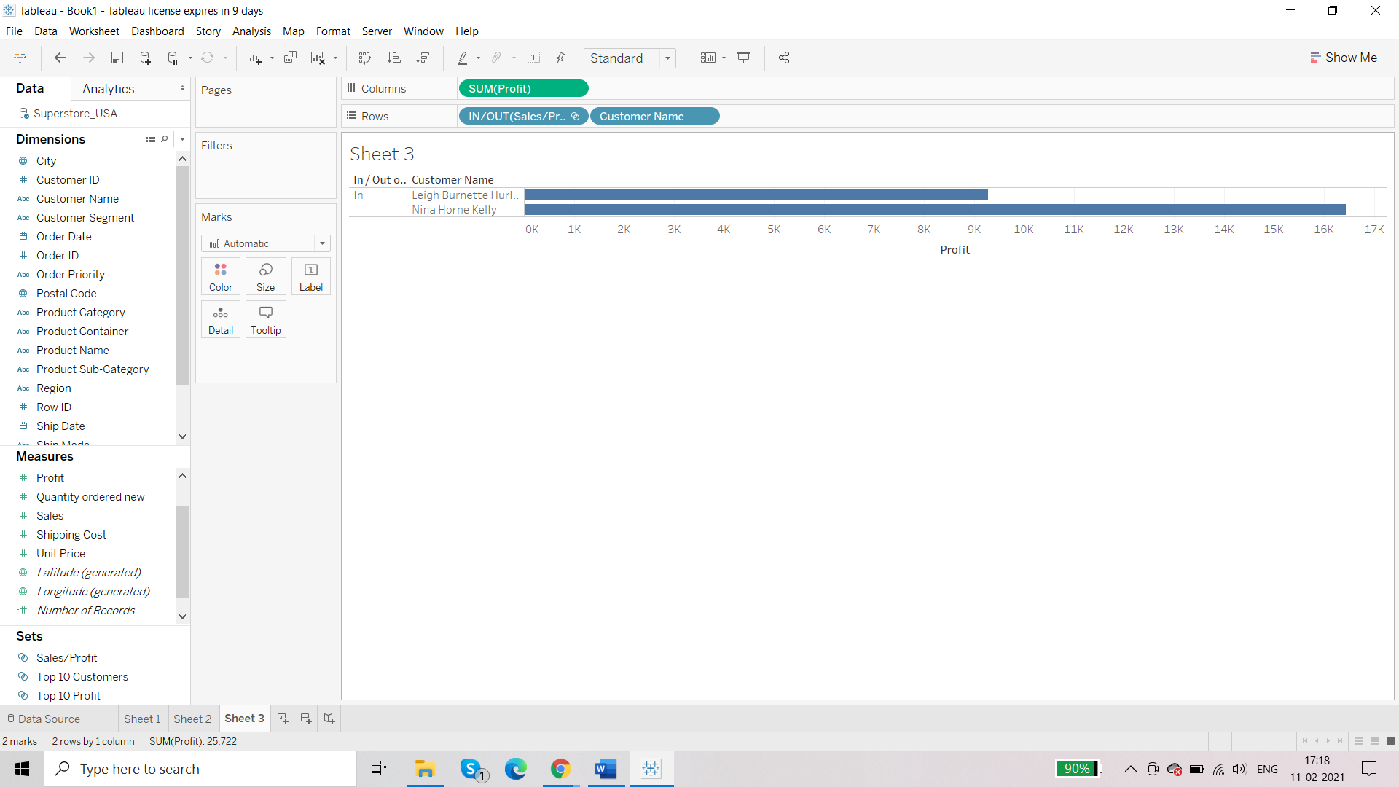So, there are 2 customers who have not only brought sales but also profit to the organisation.

**Requirement: top 100 customers in terms of profit**

Starting with basic table:

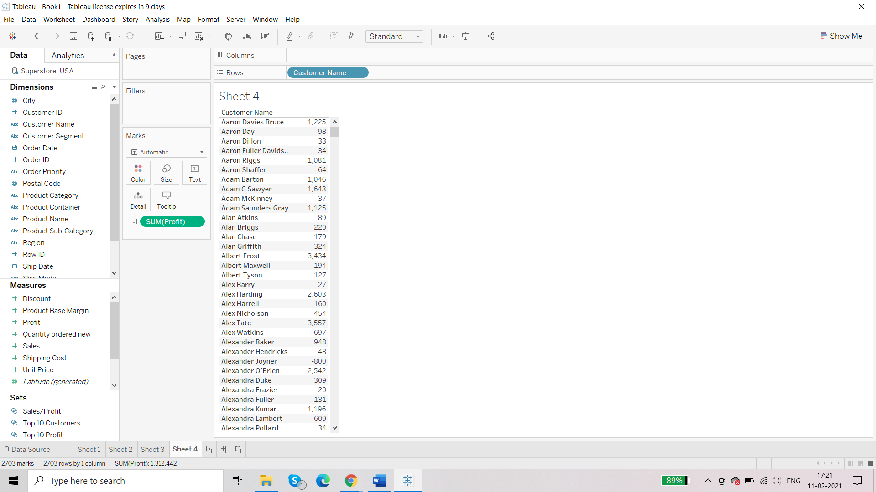

Go to ‘Customer Name’

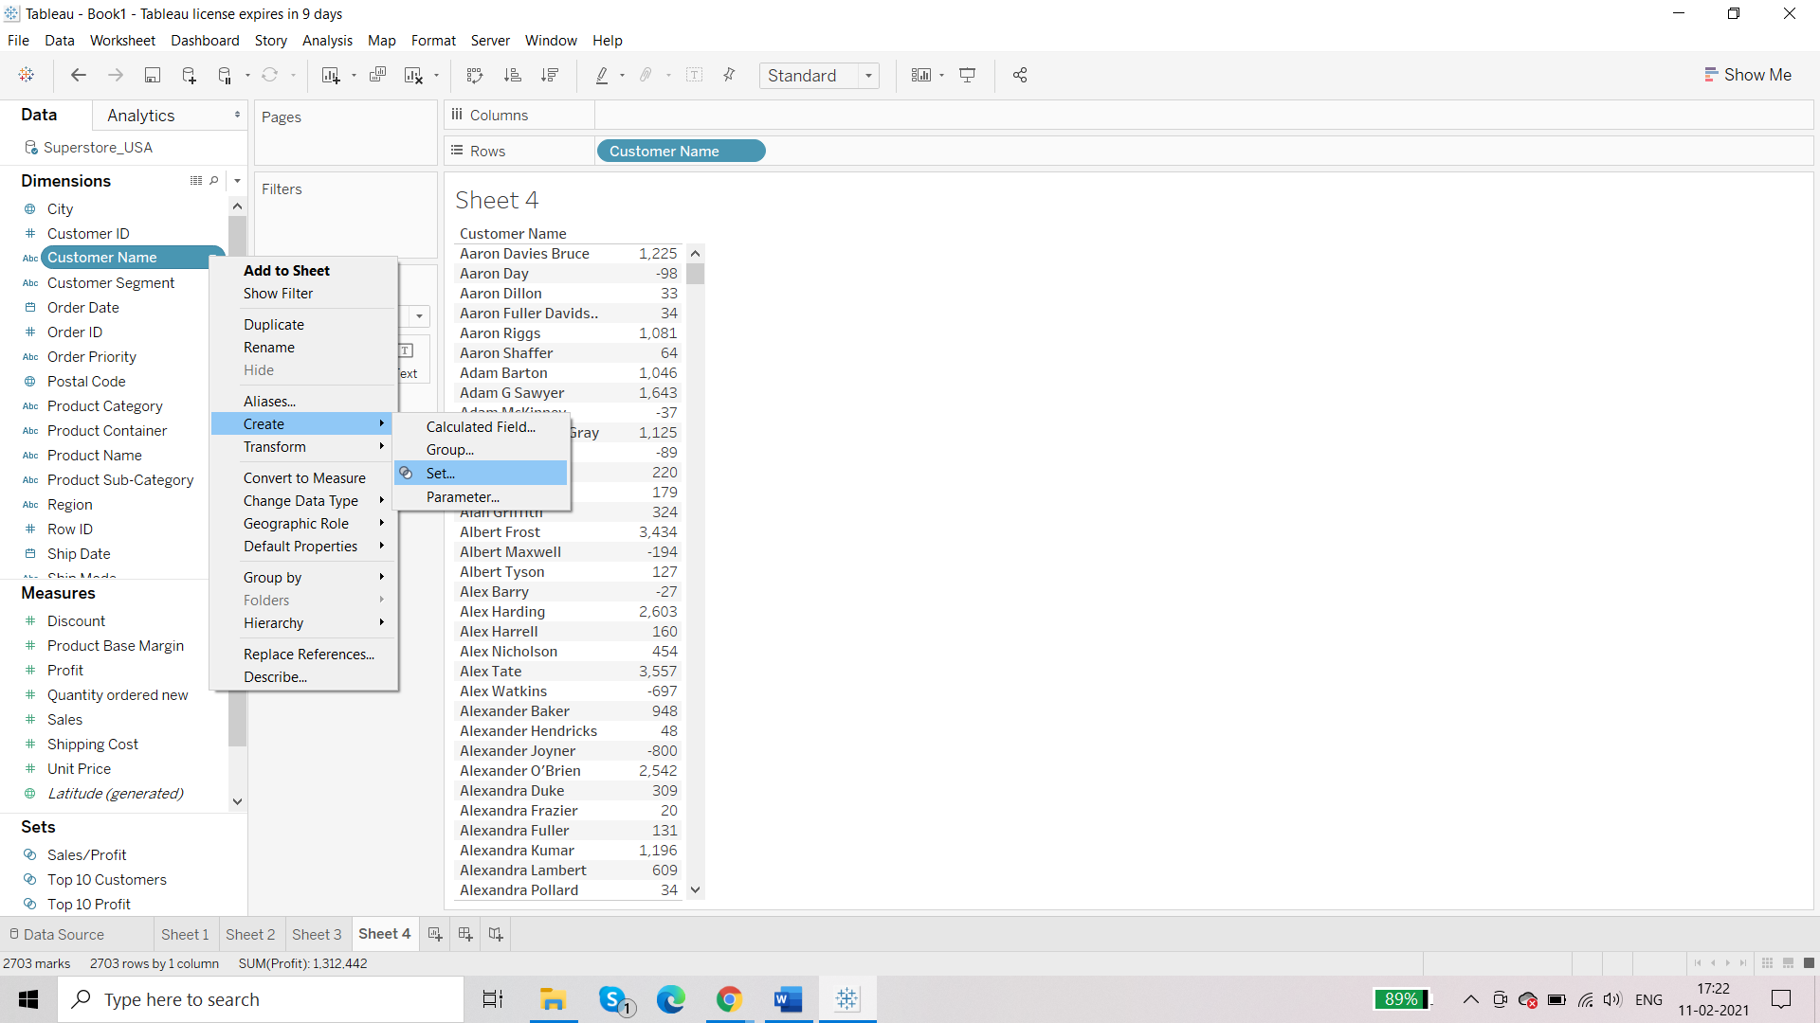

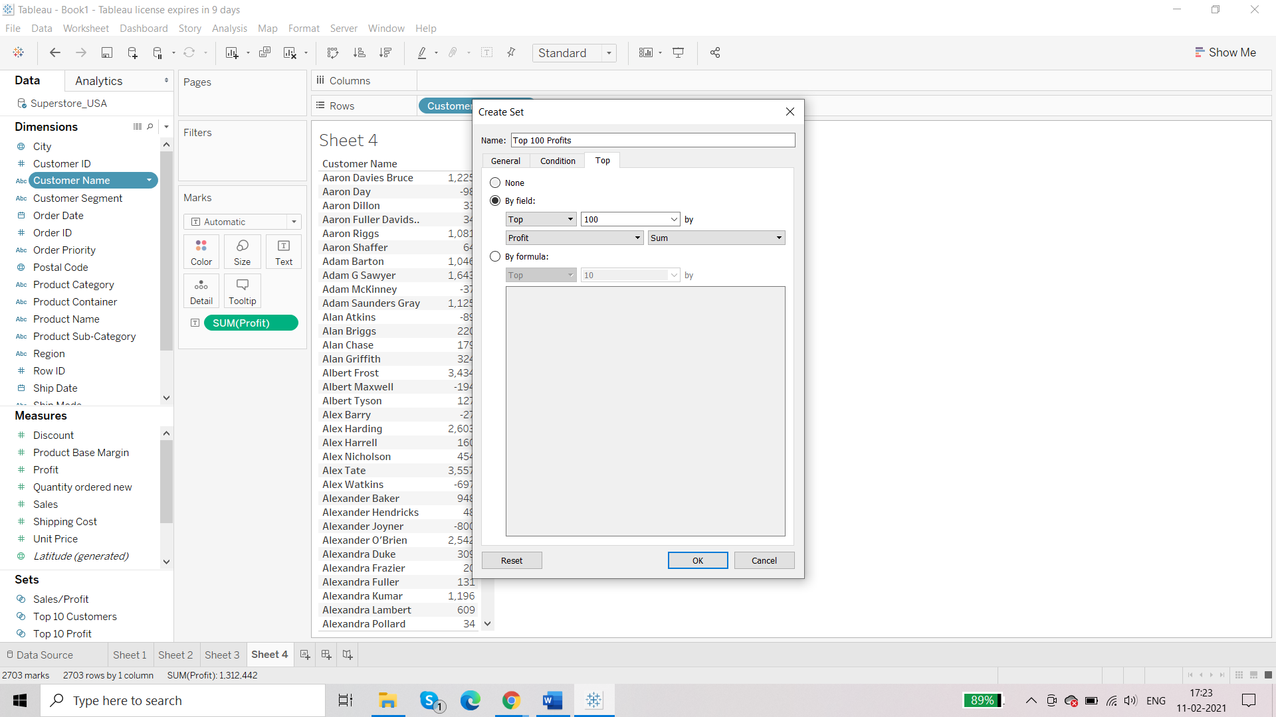

Bring the field to rows:

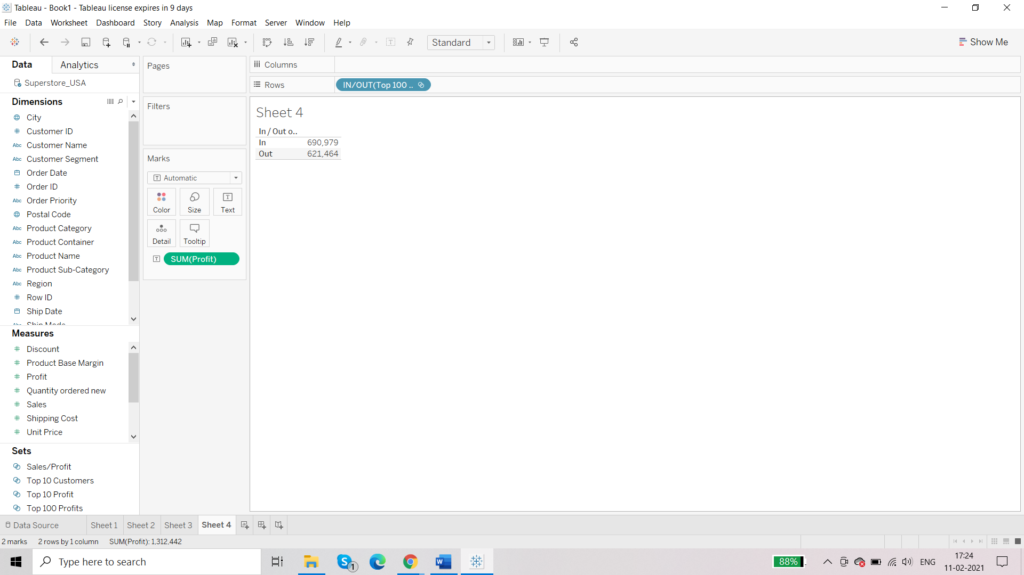

**Requirement: customers with positive profits only and customers with negative profits only**

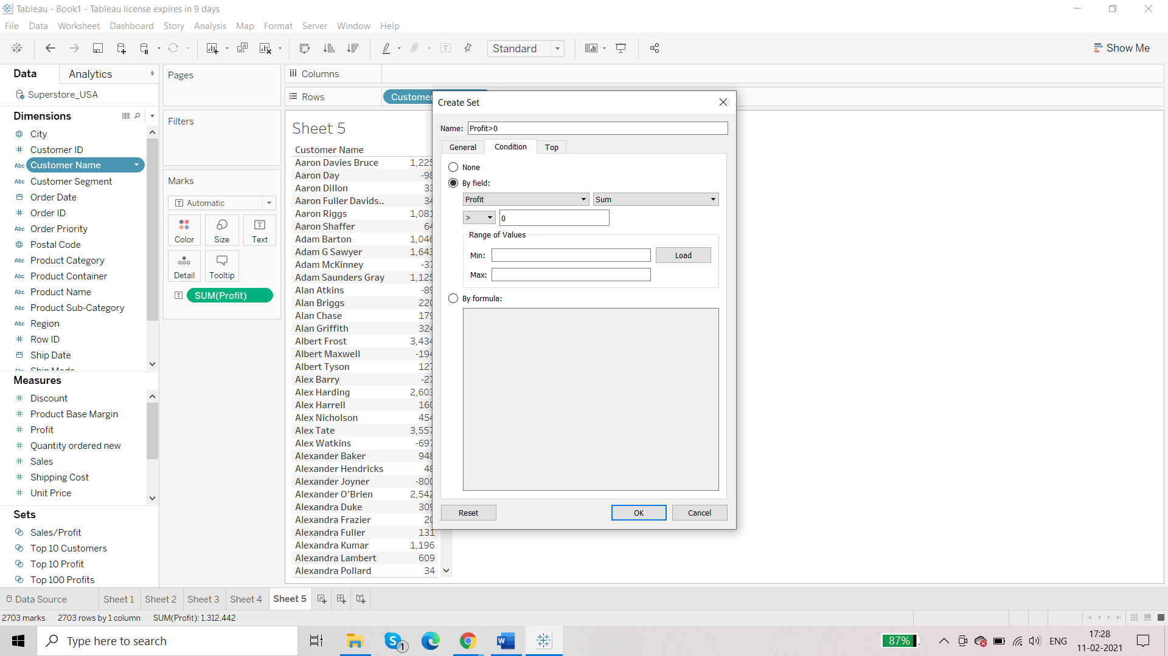

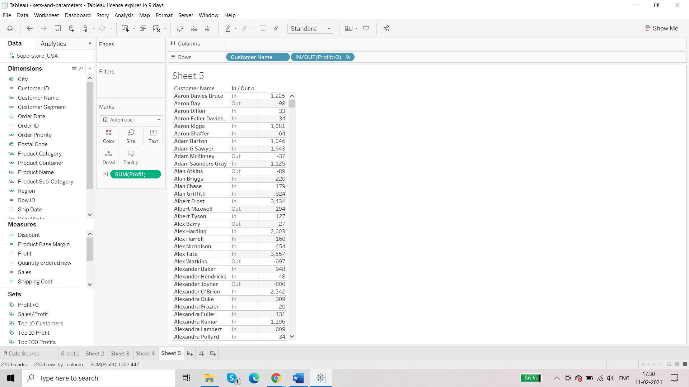

For IN: positive profit

OUT: negative profit

Parameter:

* Create a parameter
* Define the action of the parameter
* Integrate the action with the report

String Parameter

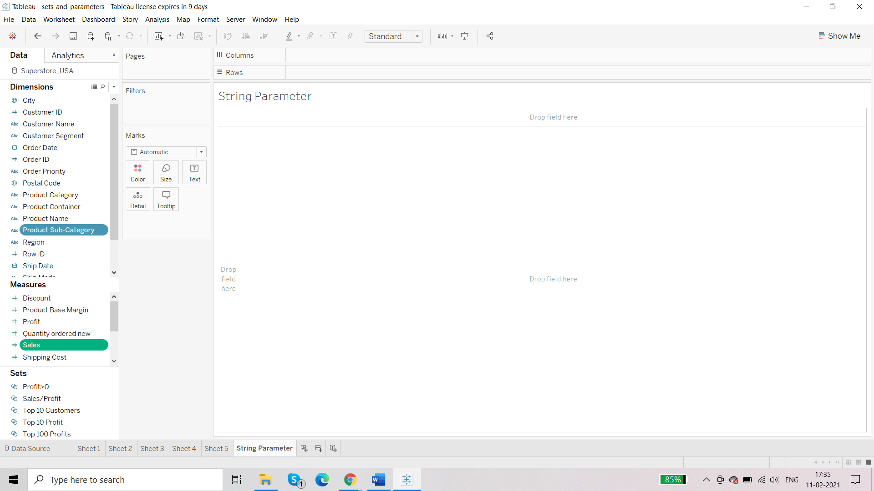

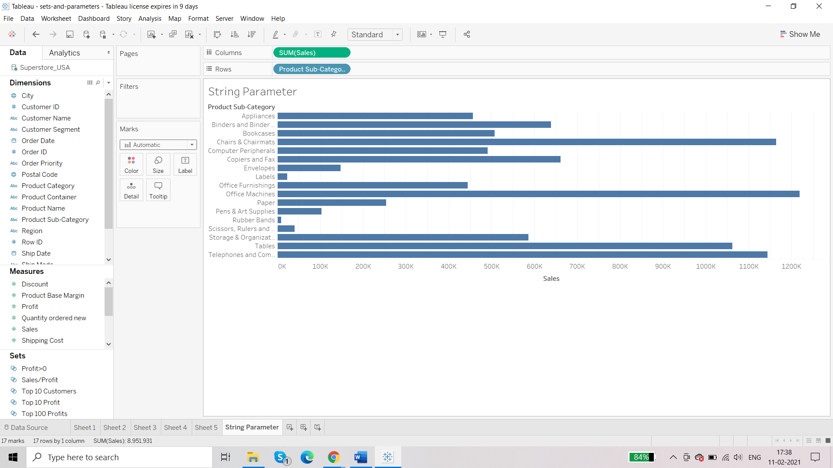

**Requirement: we want to give the end user to have the options ‘Profit, Sales’ such that when the user selects Profits the report gets sorted in terms of profit and if the user selects Sales the report gets sorted in terms of sales**

We will first create the parameter:

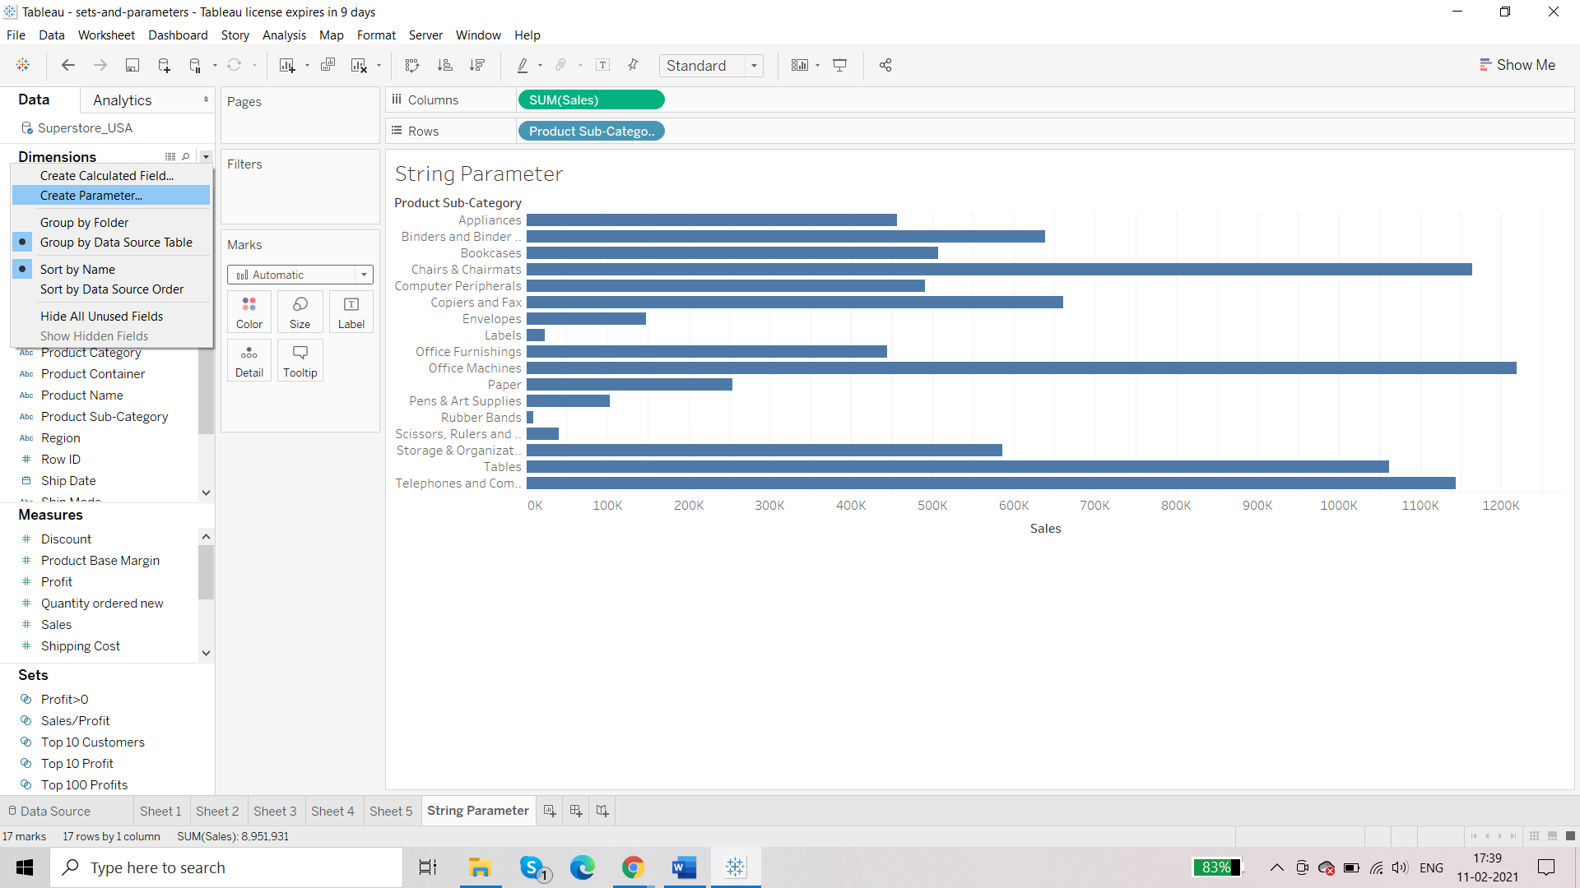

Profit and Sales are listed as string

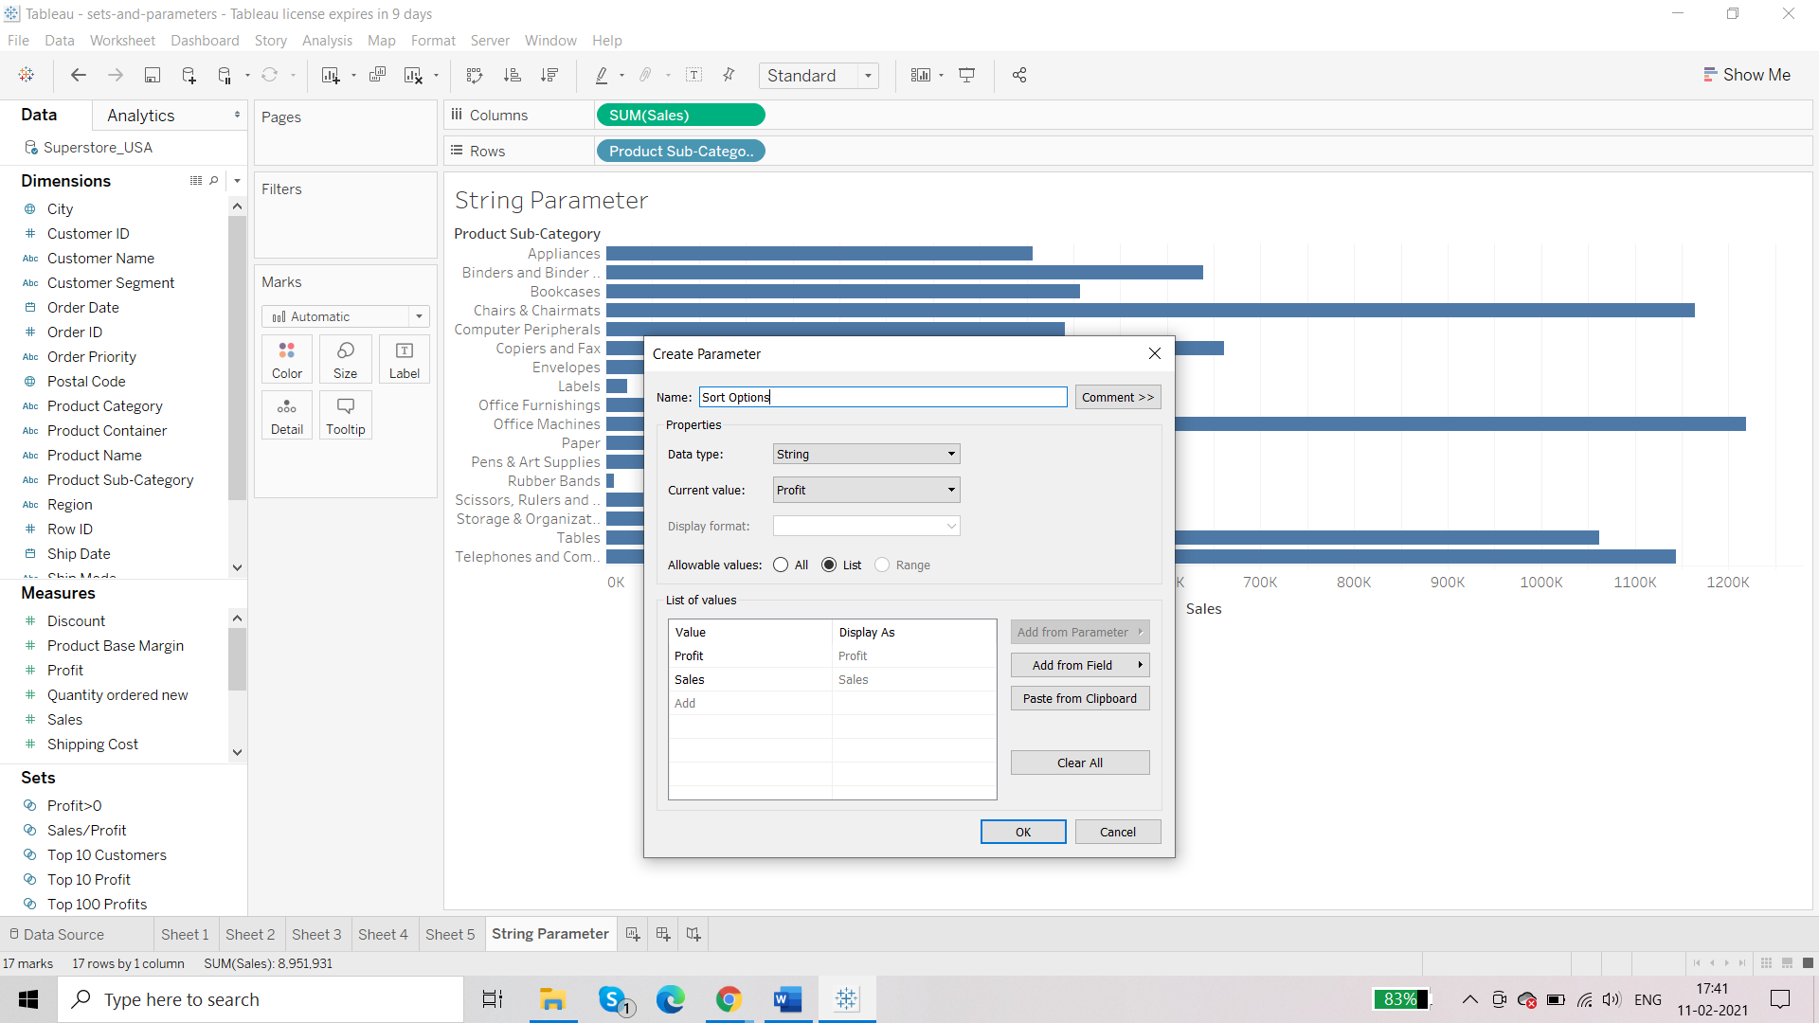

Bottom left:

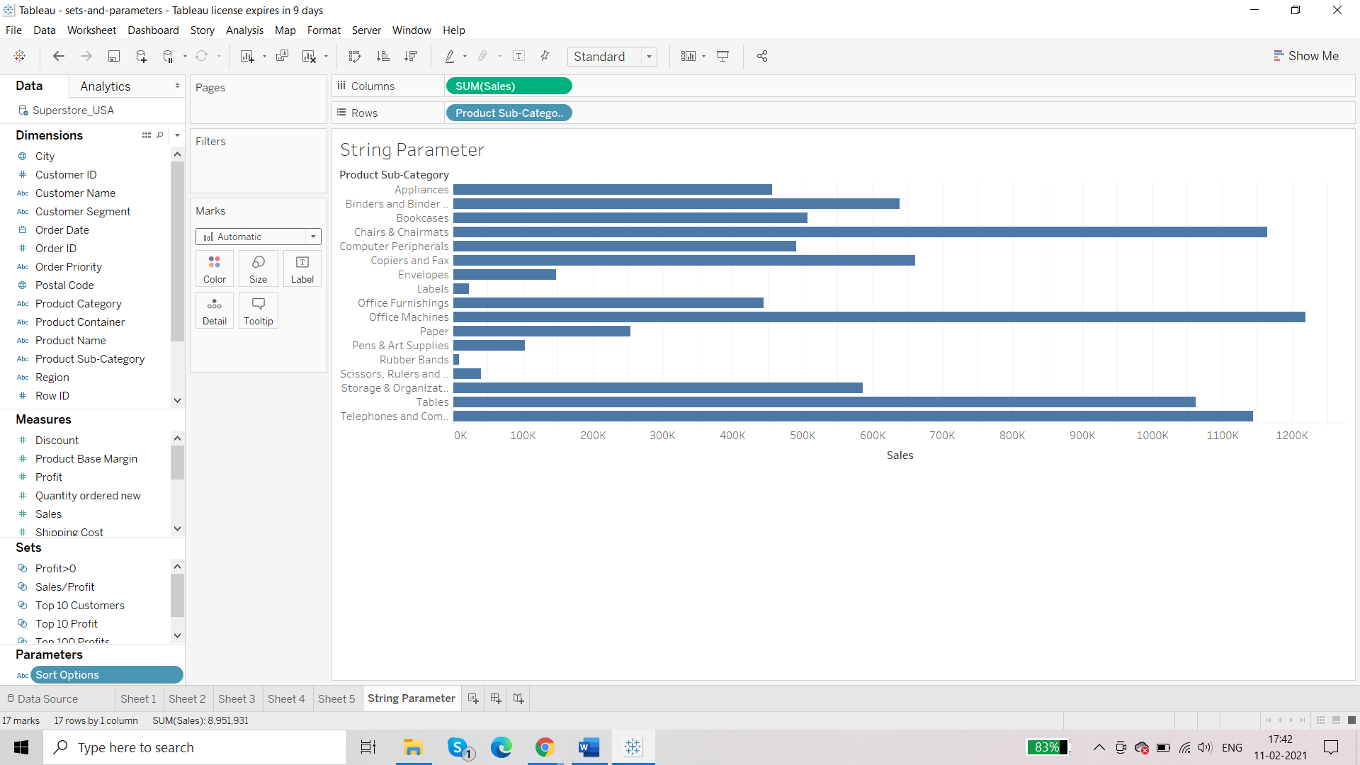

So, parameter is created but it’s not working because we have not defined the action yet.

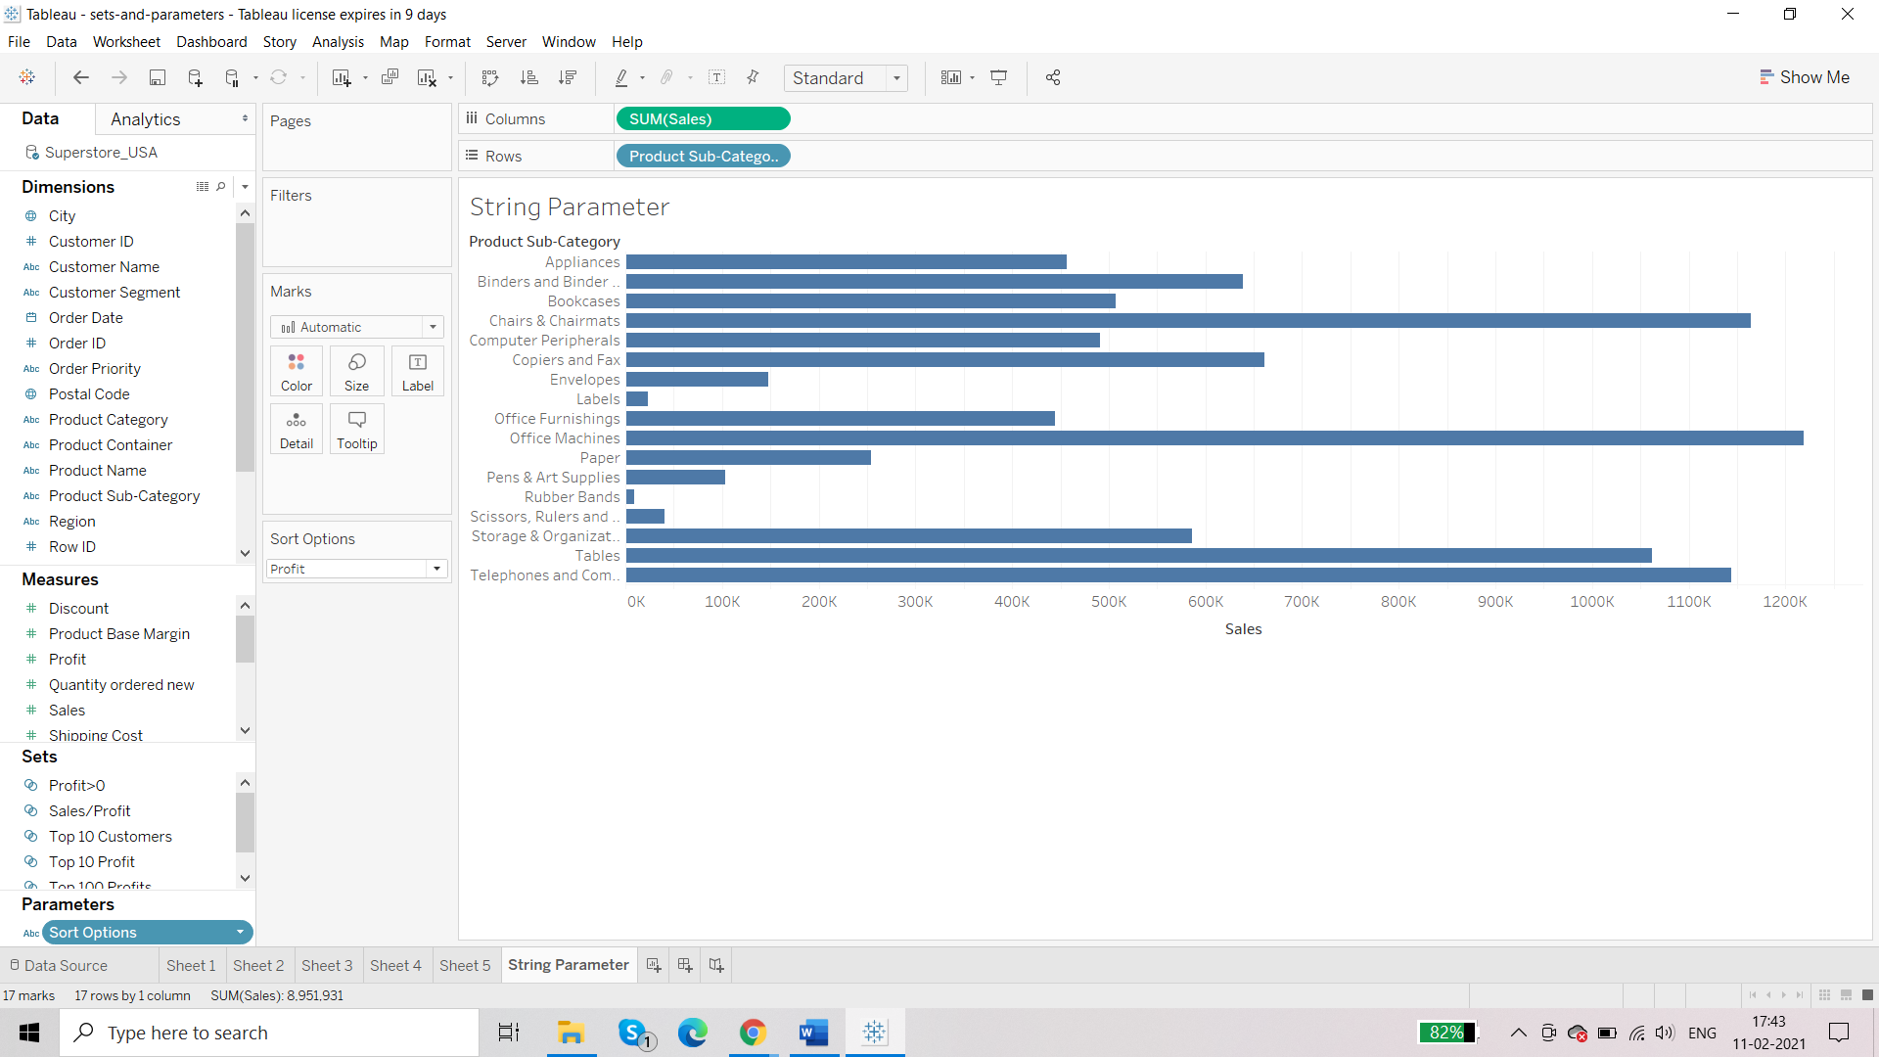

Most popular way to create action for parameter is through calculated field:

Calculated Field is simply a place in tableau where we write all formulas and functions.

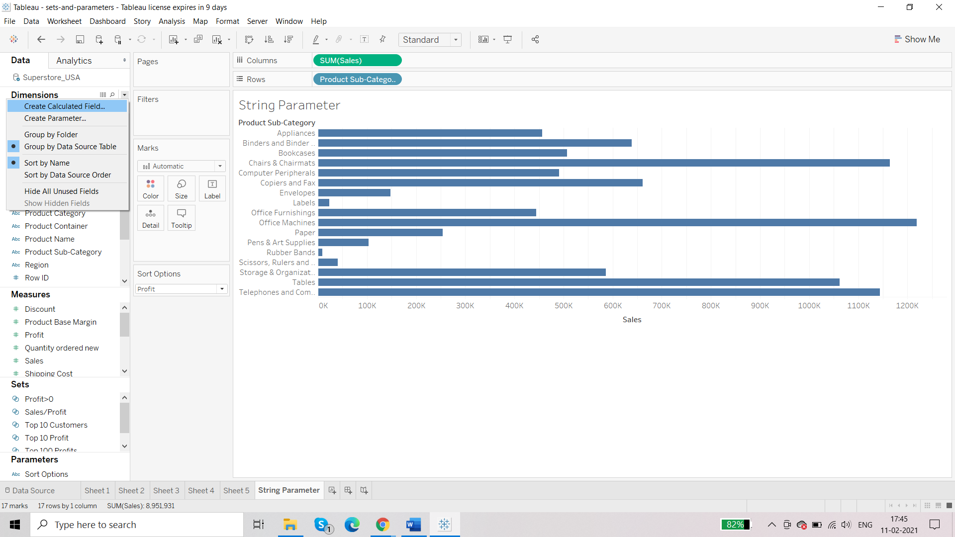

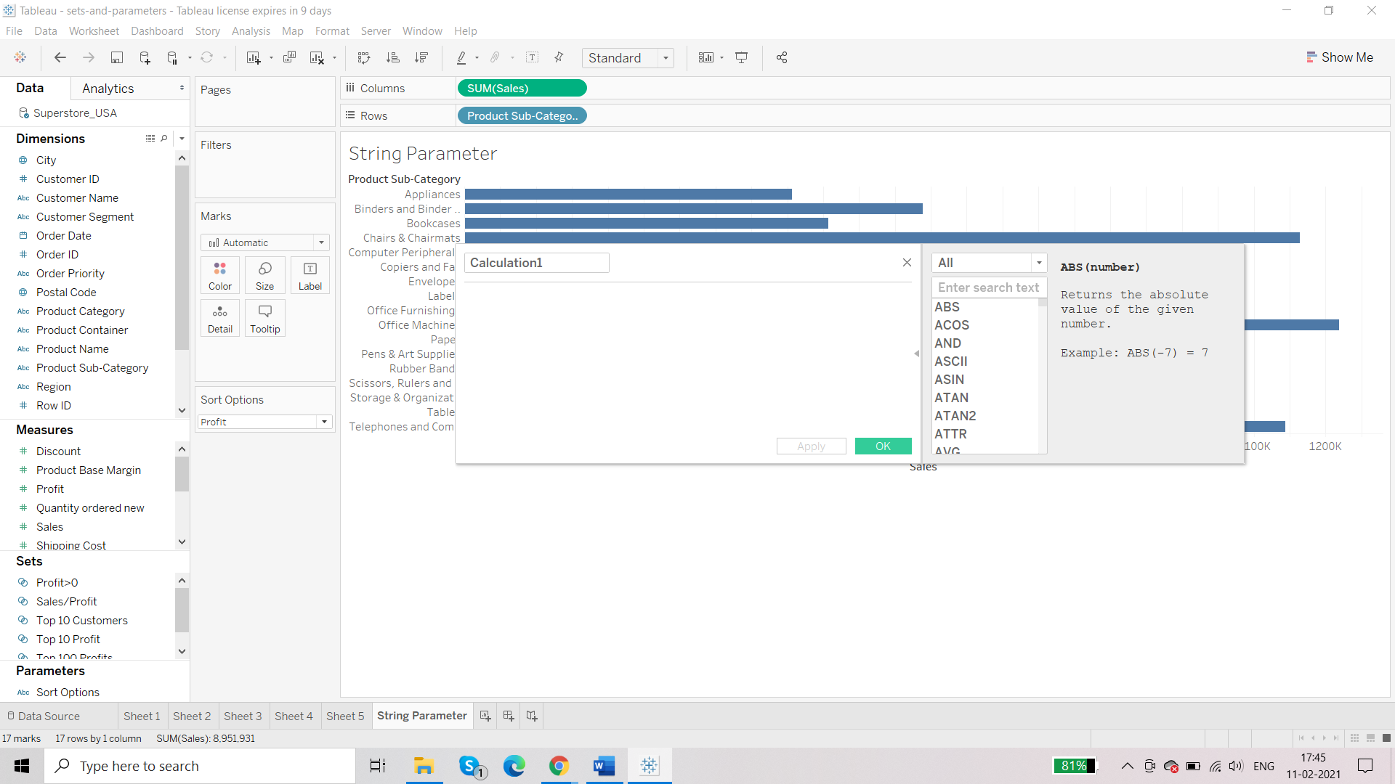

CASE [Sort Options]

WHEN "Sales"

THEN [Sales]

WHEN "Profit"

THEN [Profit]

END

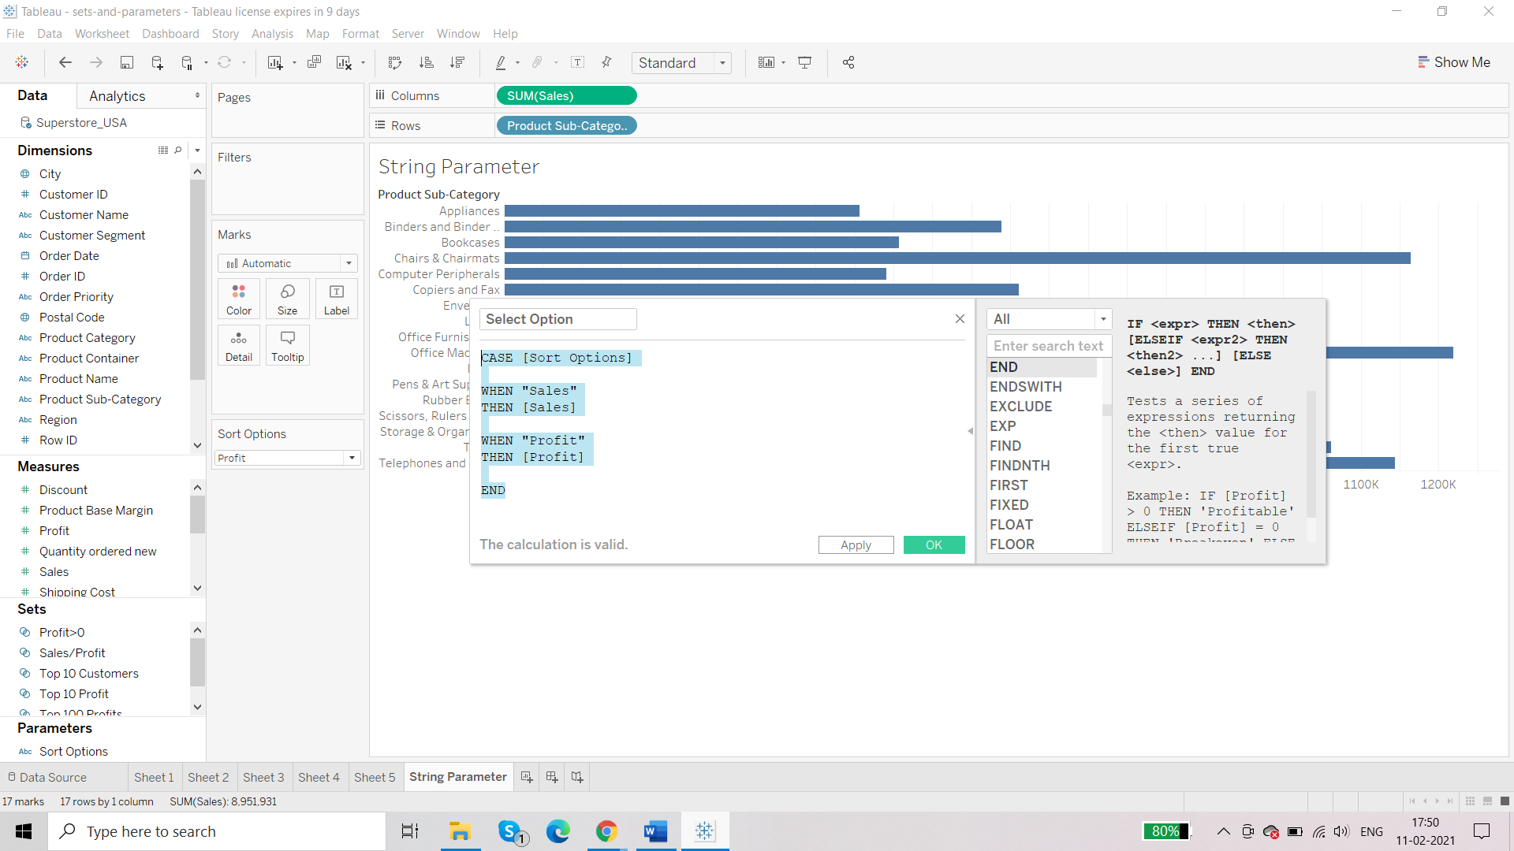

So, we have got a new measure:

All the user defined measures have = sign followed by datatype

Or user defined dimension

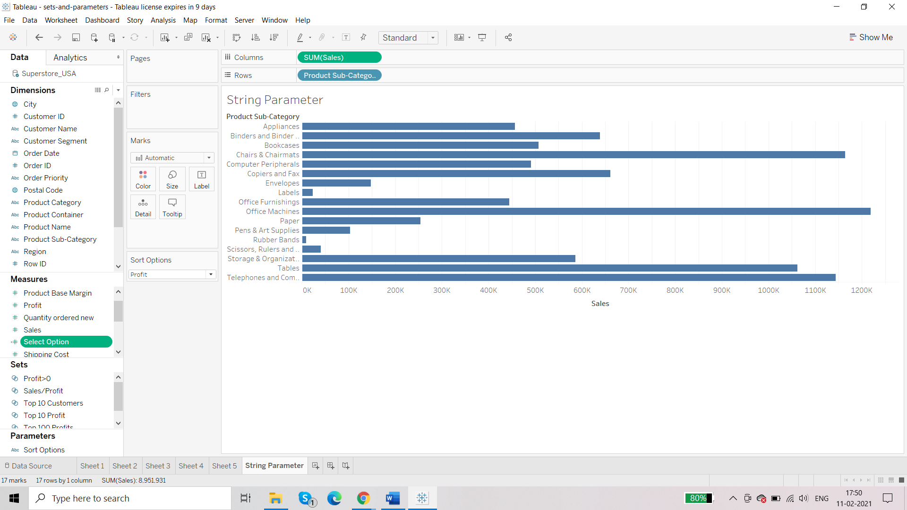

Third part:

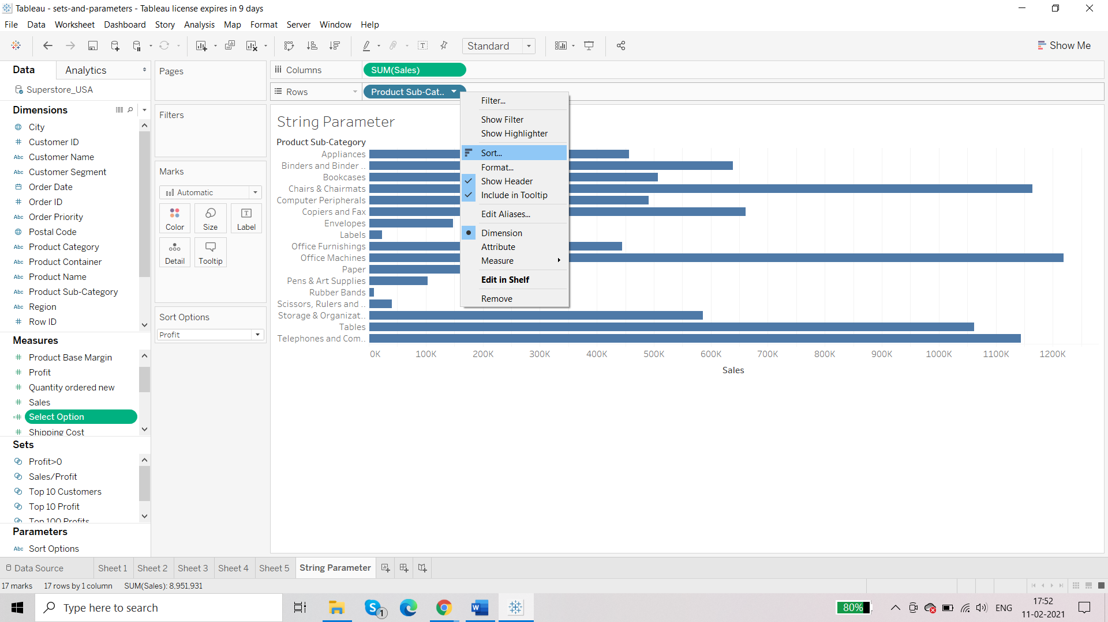

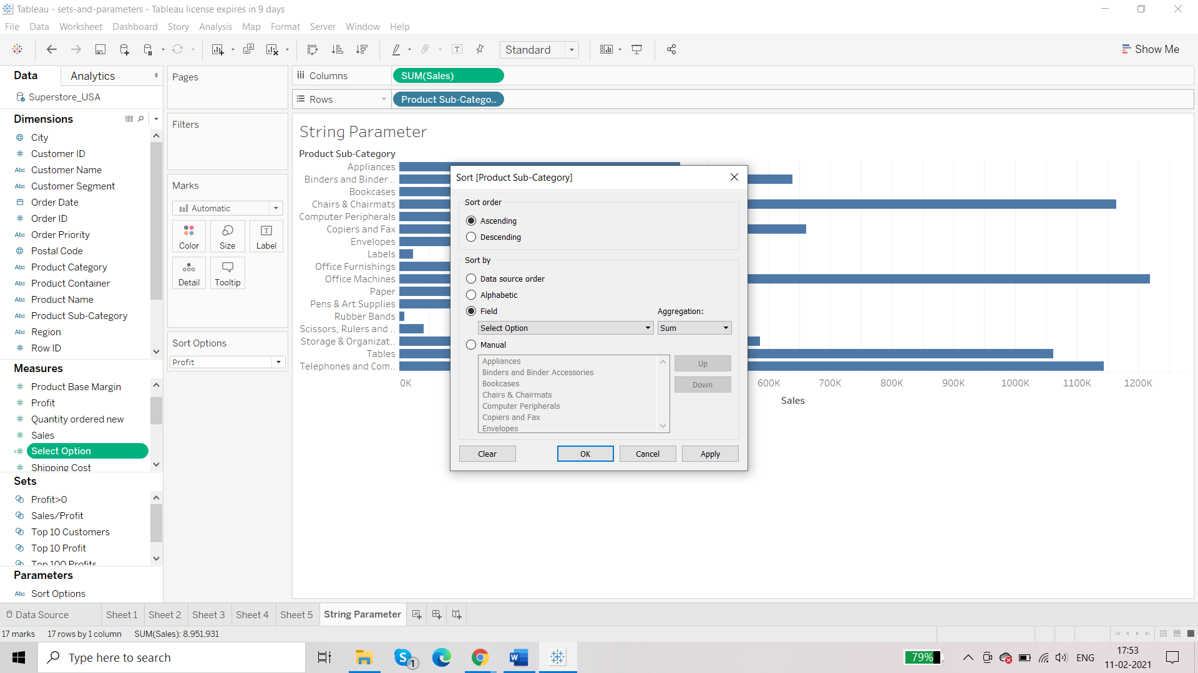

End user:

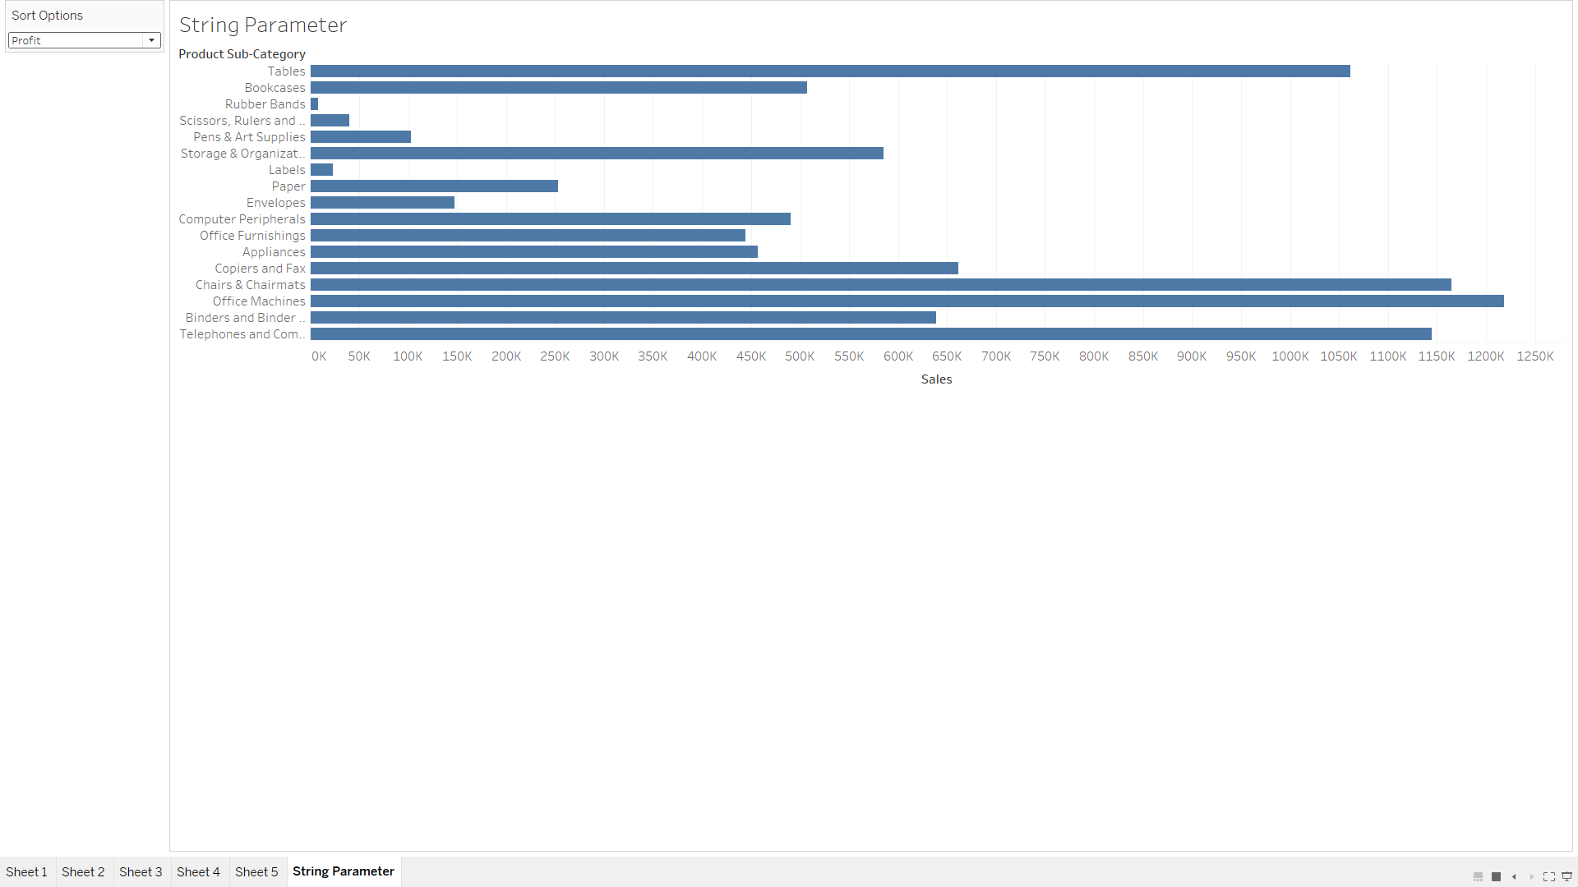

**Requirement: Forecast sales in terms of profit. How much sales is the company going to earn if the profit increased by 5%monthly**

This kind of analysis is known as WHAT IF ANALYSIS

Taking OrderDate and Sales plot a line chart:

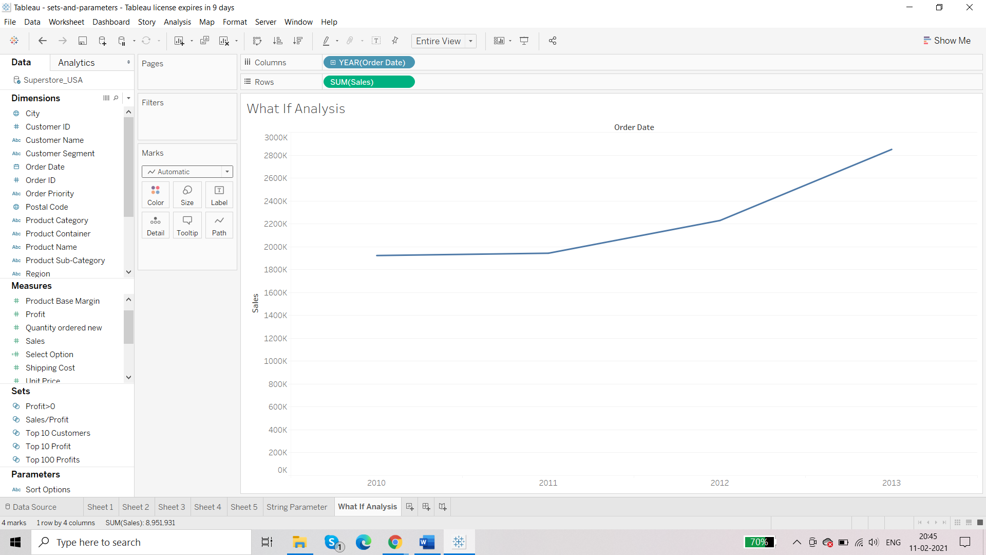

Change the hierarchy from discrete to continuous:

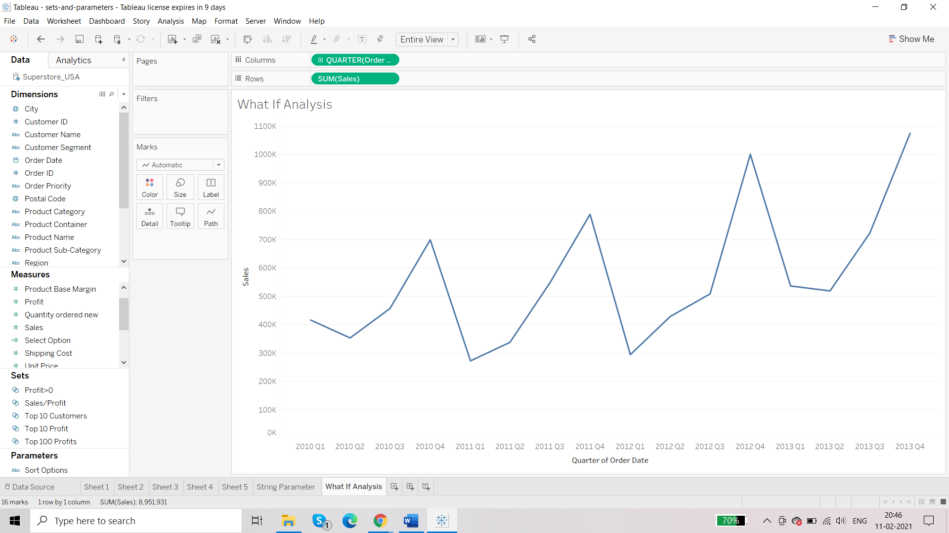

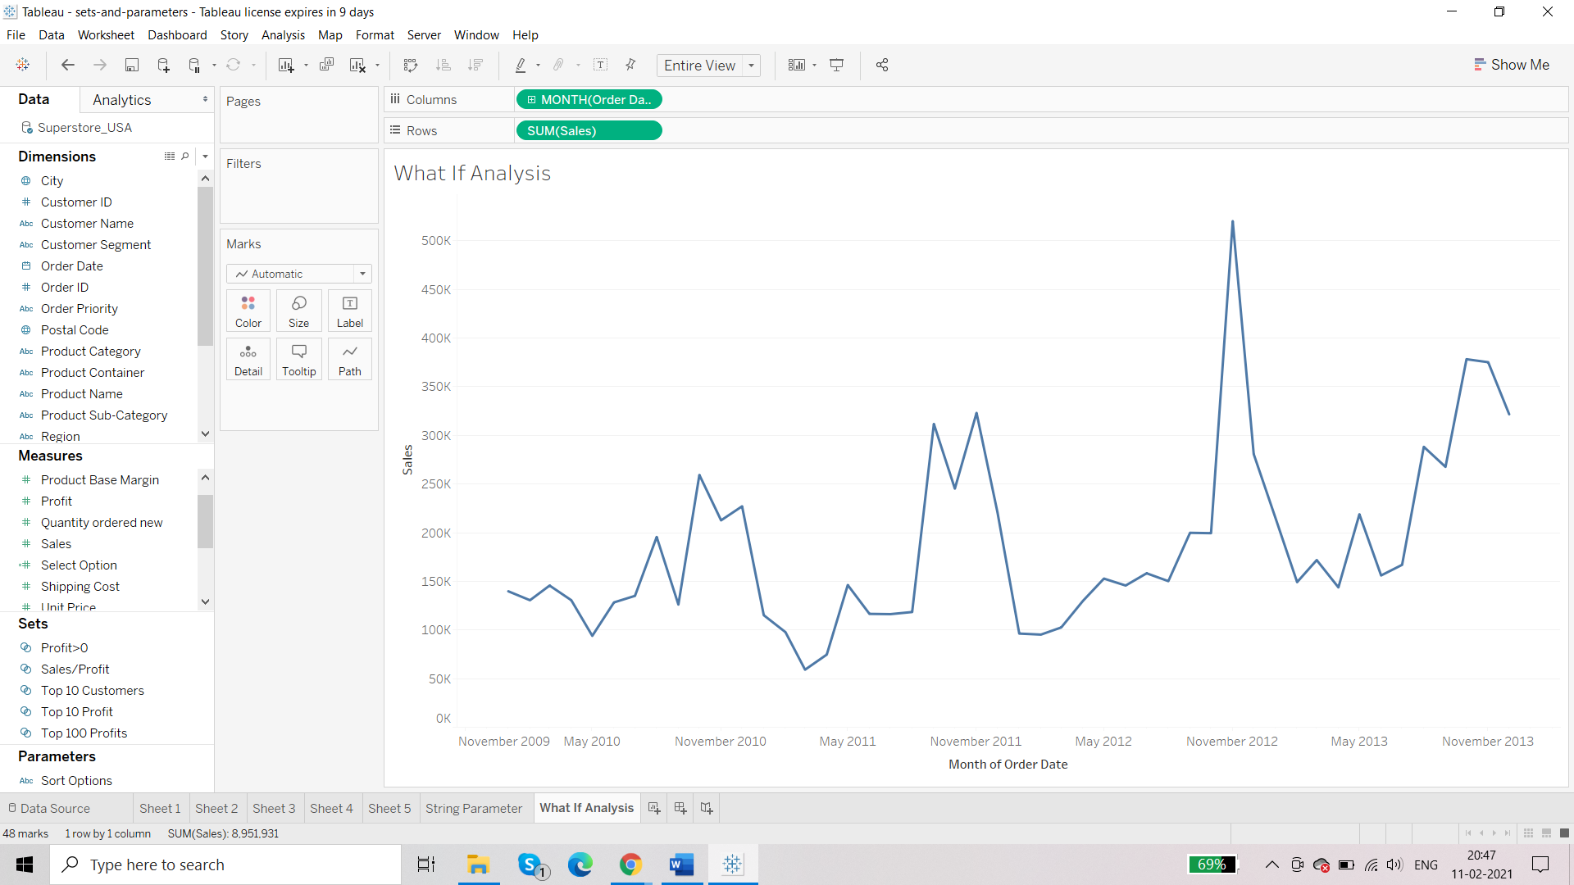

Create a new parameter: Growth Rate

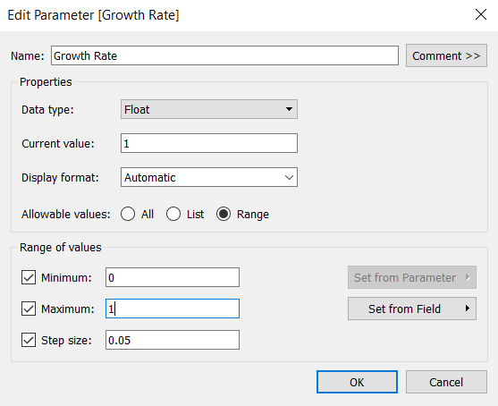

Edit the format to percentage:

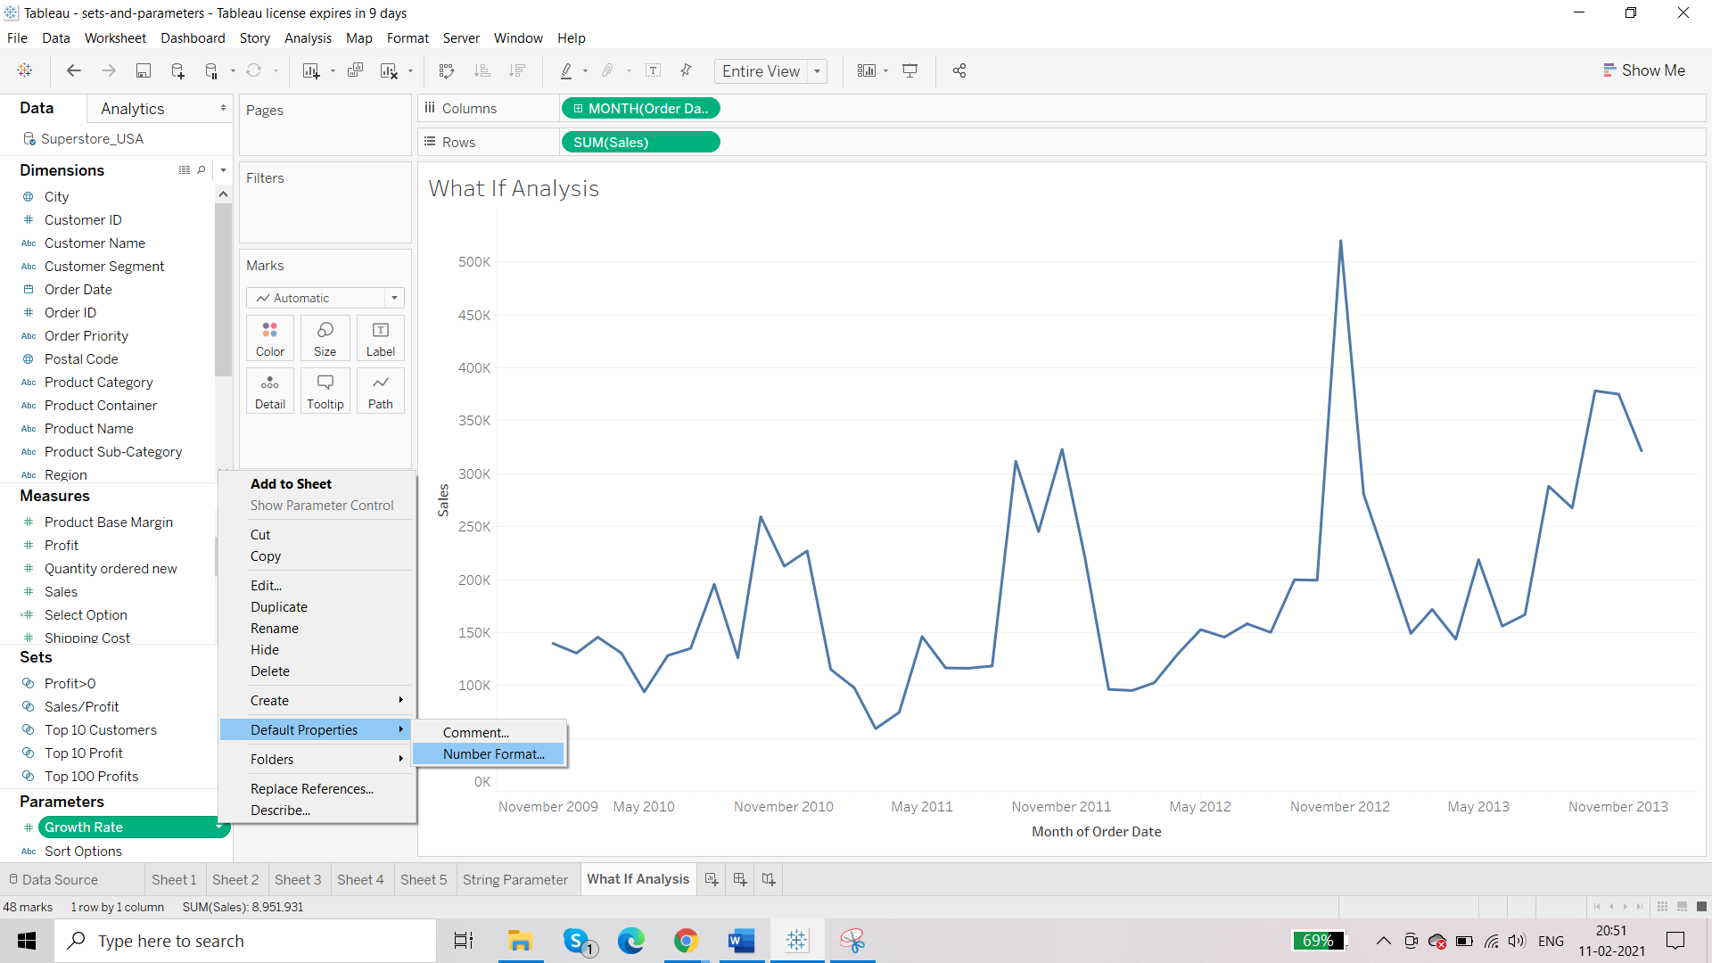

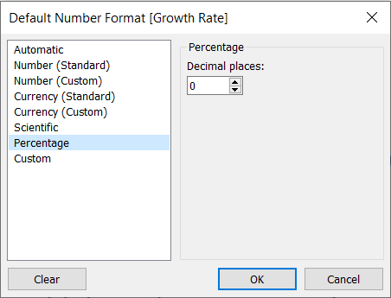

Slider increases at 5% till 100%.

Now we will make a calculated field as the action to the parameter:

Select Growth

SUM([Sales])*(1+[Growth Rate])

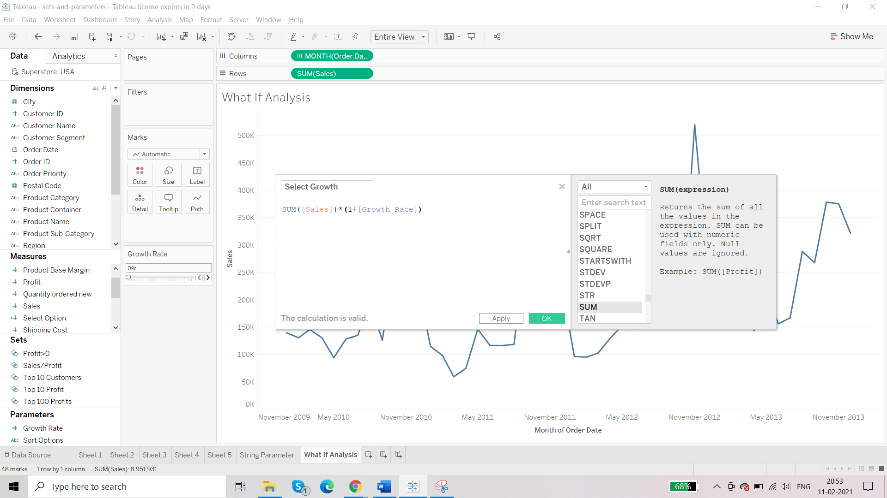

Third criteria: integrate this

Place this ‘Select Growth’ beside the Sum(Sales) pill in the rows.

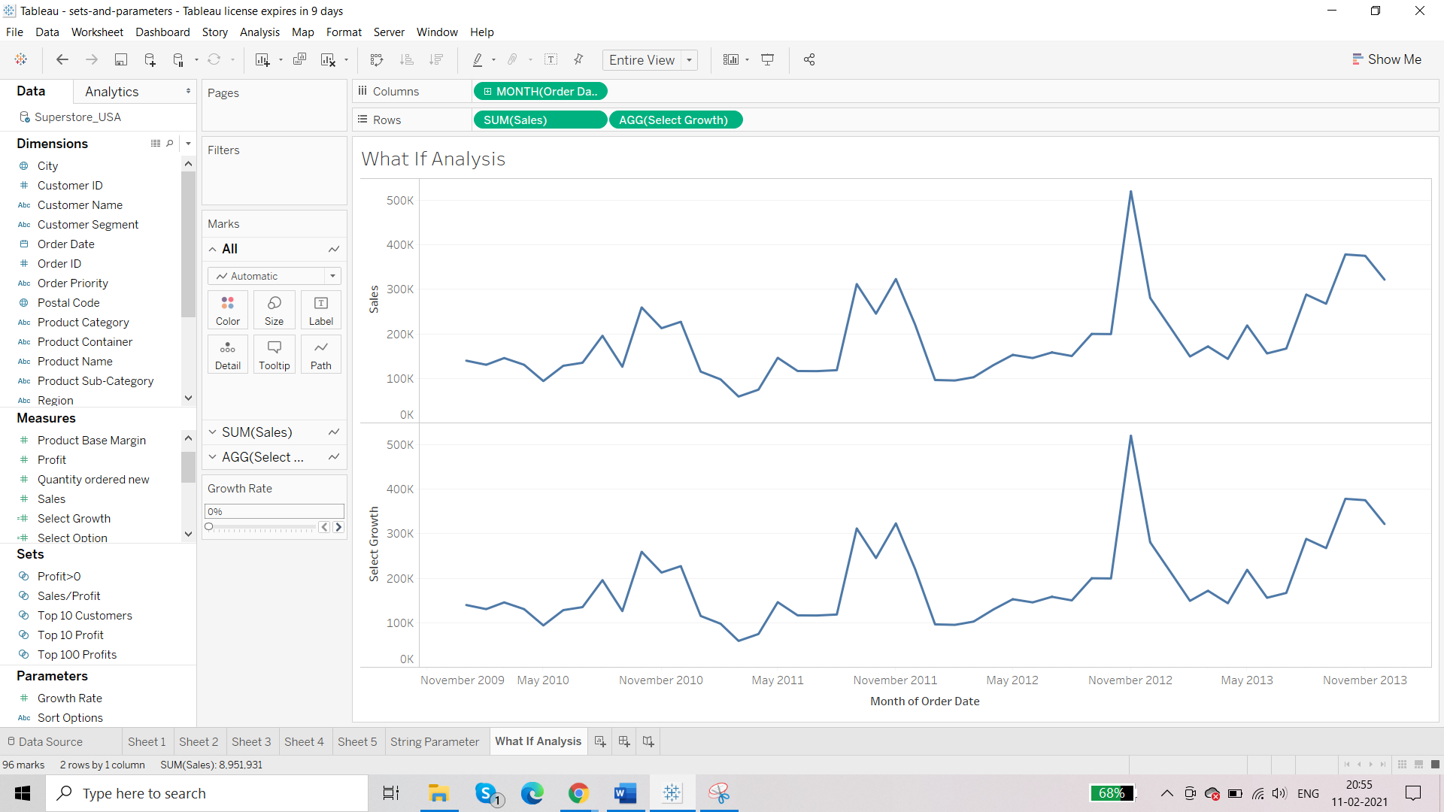

Enable dual axis

Change the colour

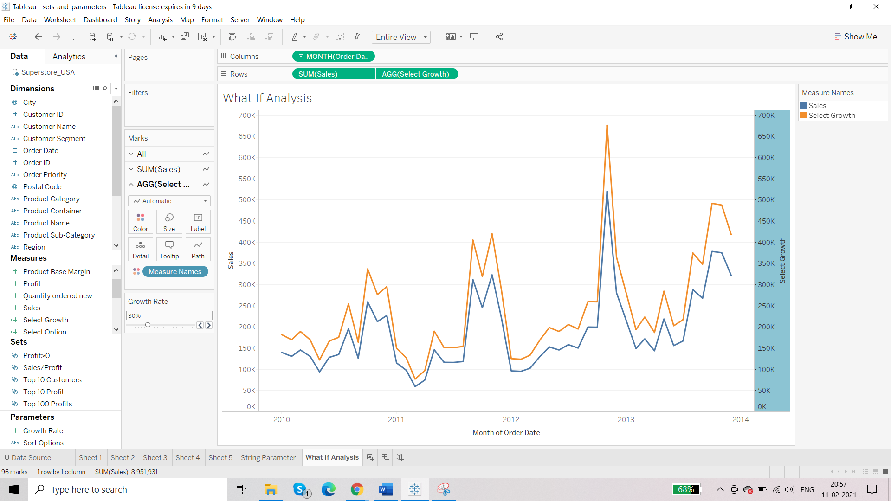

**Different approaches to calculations**

Source: DataNation

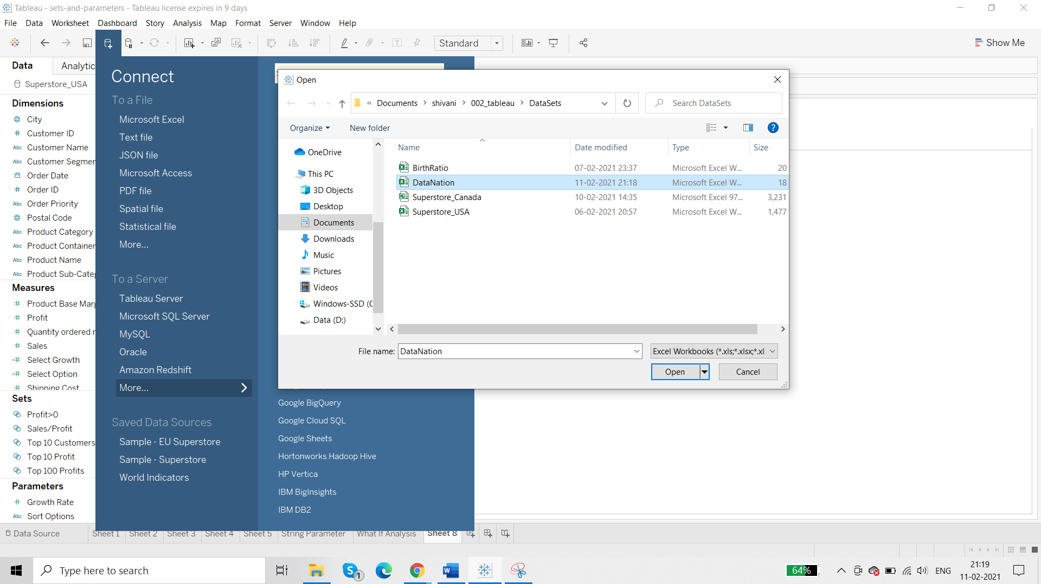

Requirement: Number of deaths in a city and in a state

We have DEATH RATE and POPULATION so we will perform calculation on that.

This is going to be a numerical calculation.

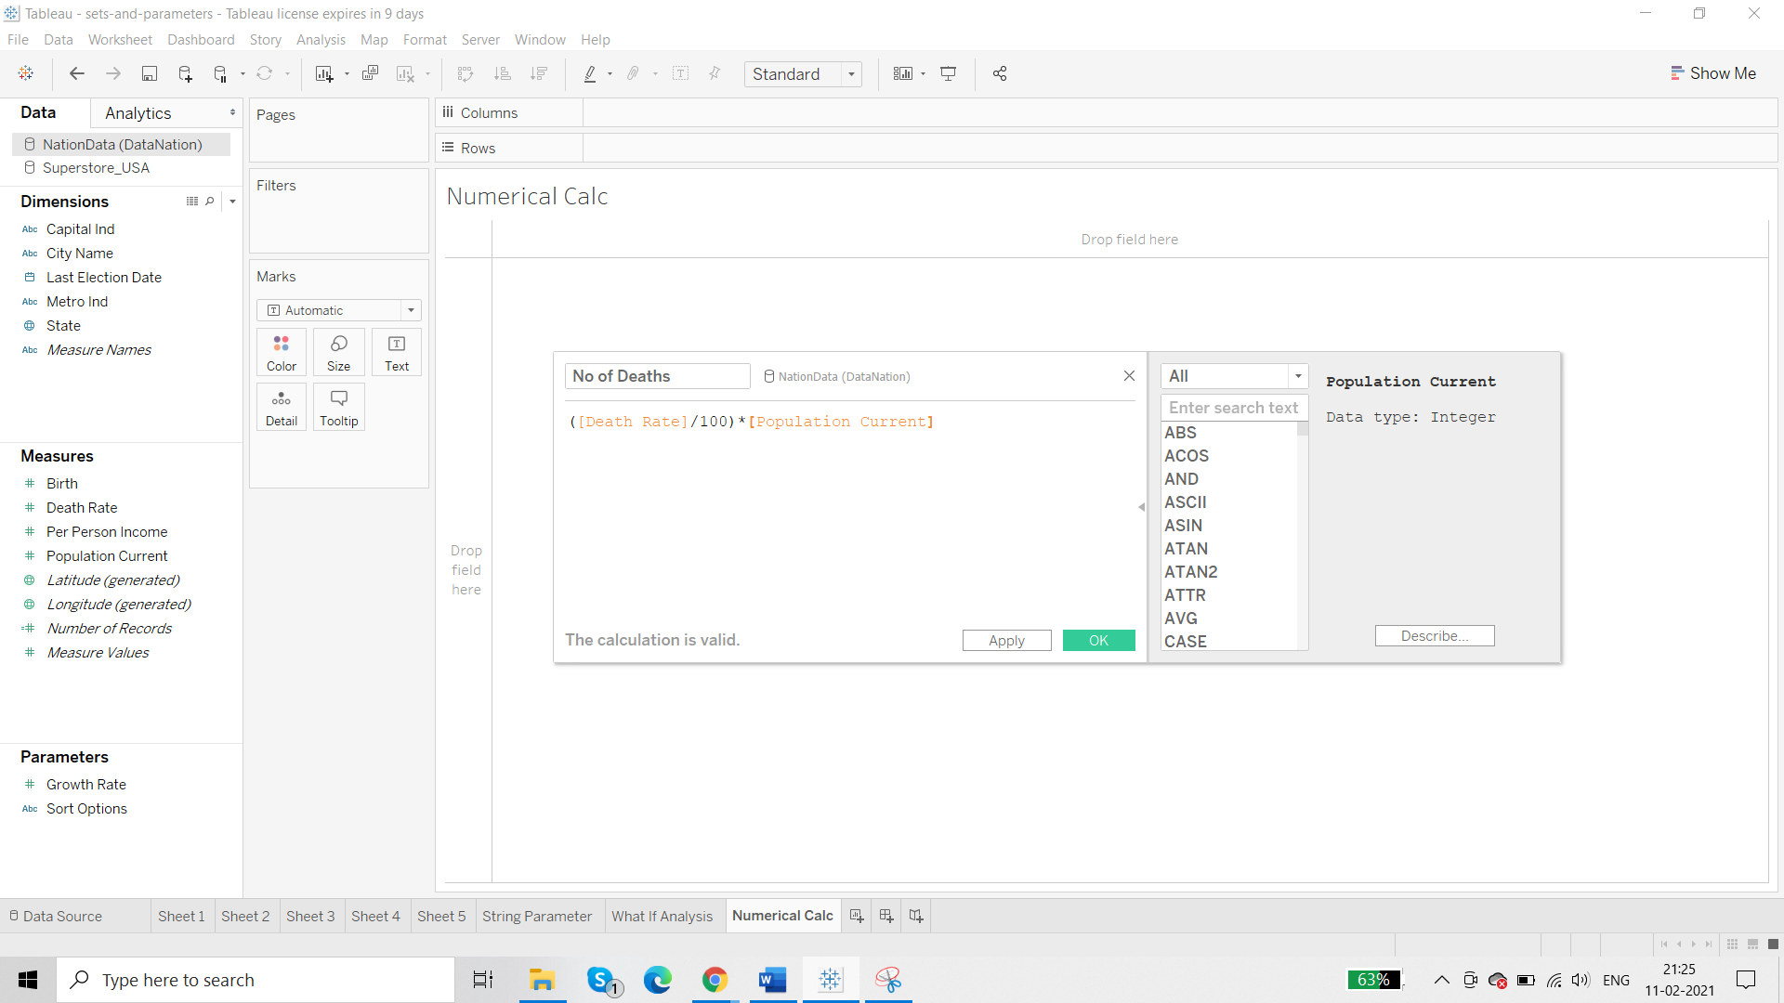

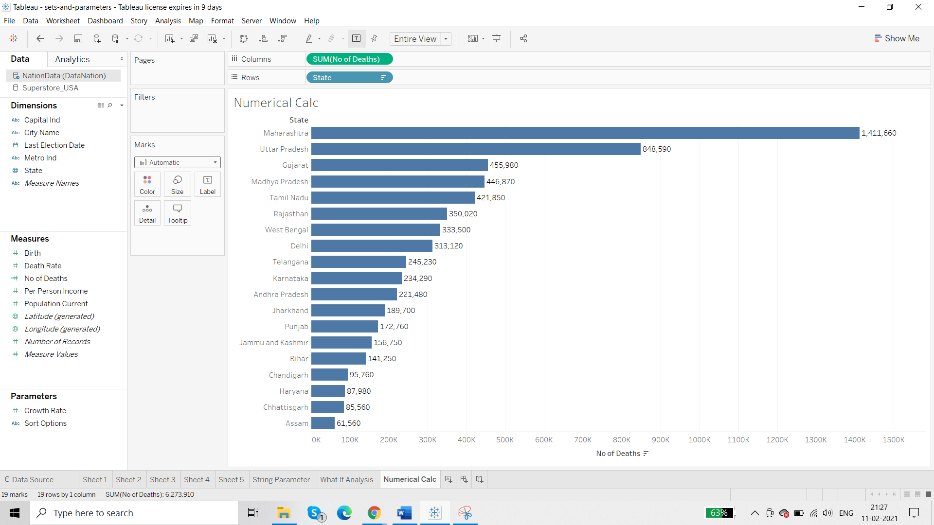

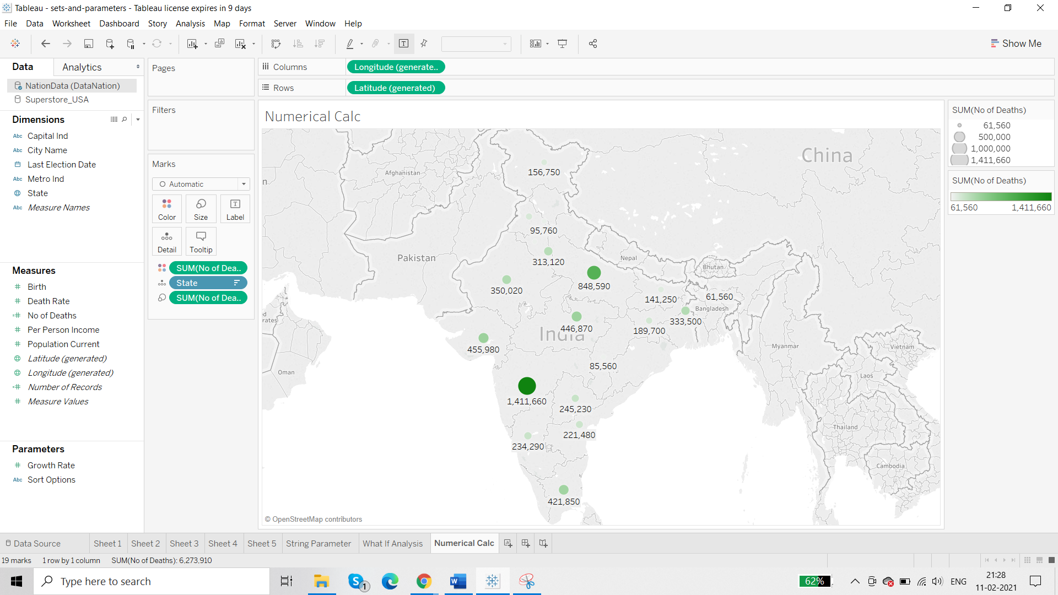

In place of State we can bring City.

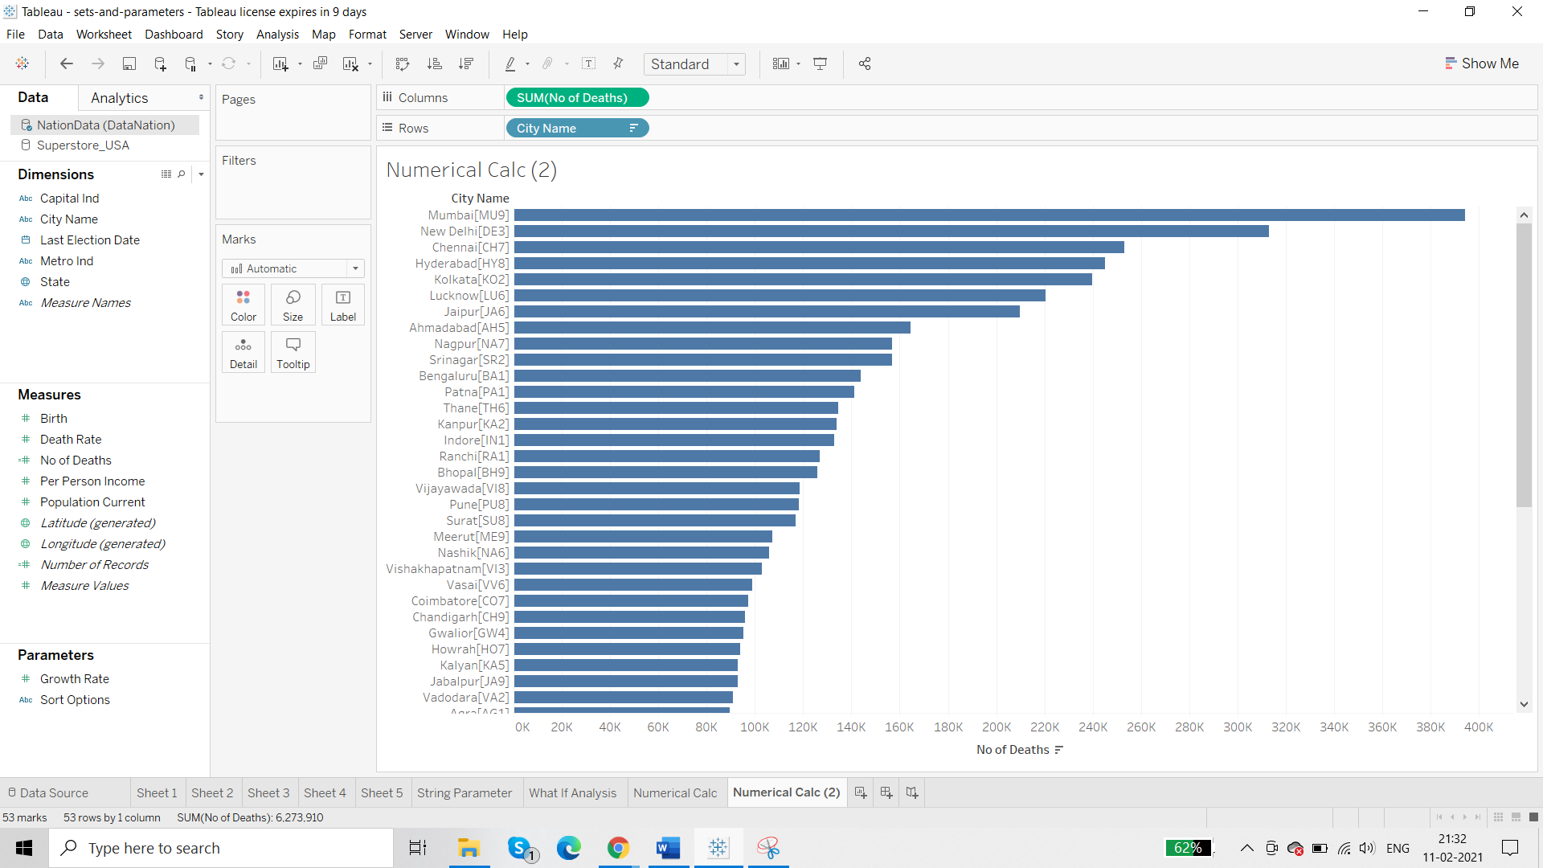we want to remove the code in front of city

This is going to be String Calculation.

**Approach 1:**

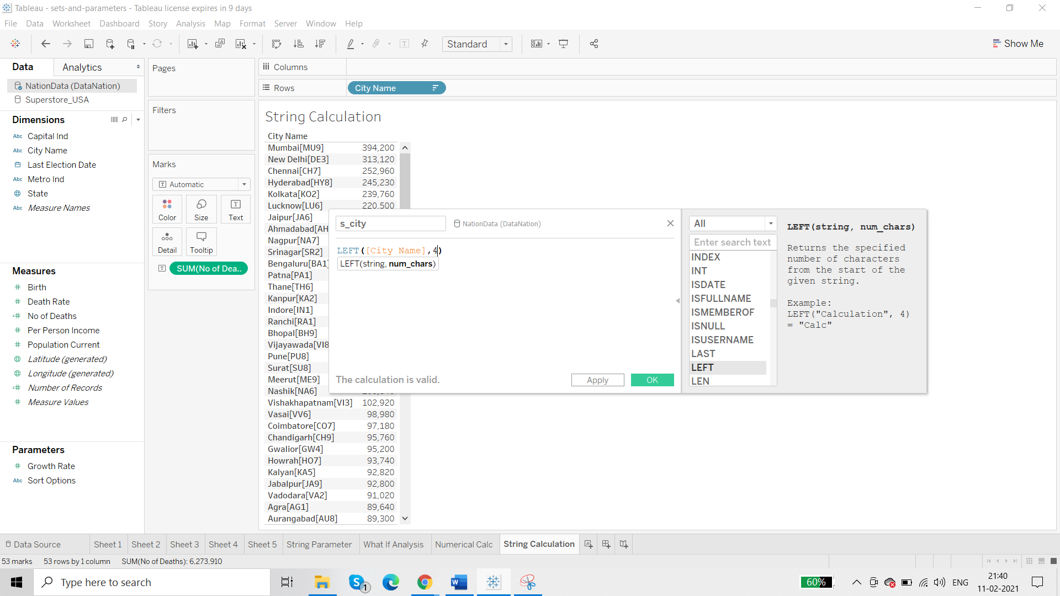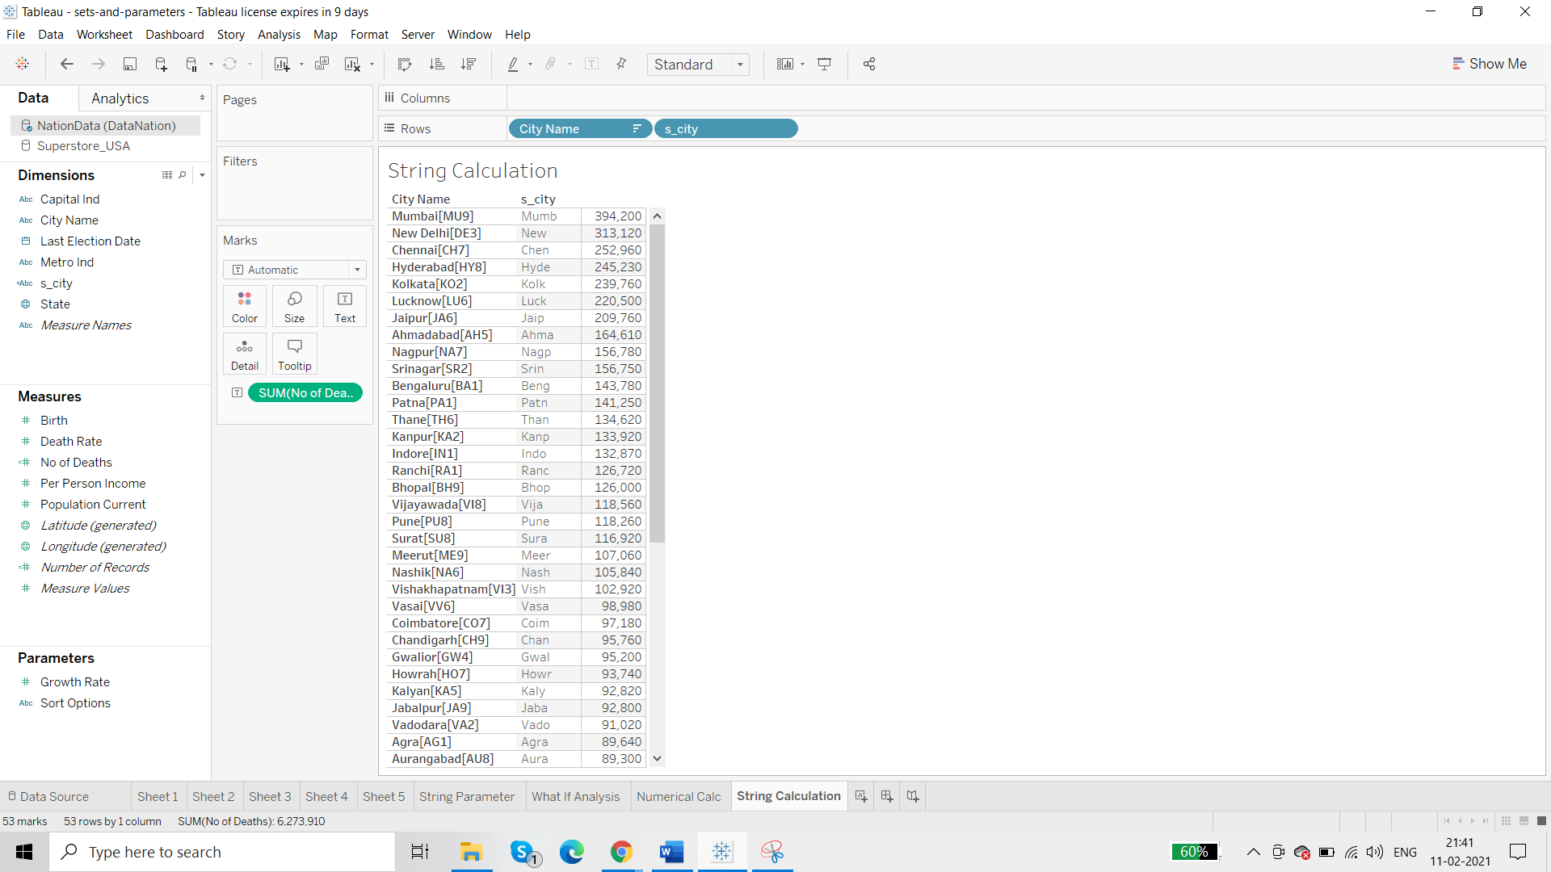

But this does not serve the purpose completely

So we create another calculated field:

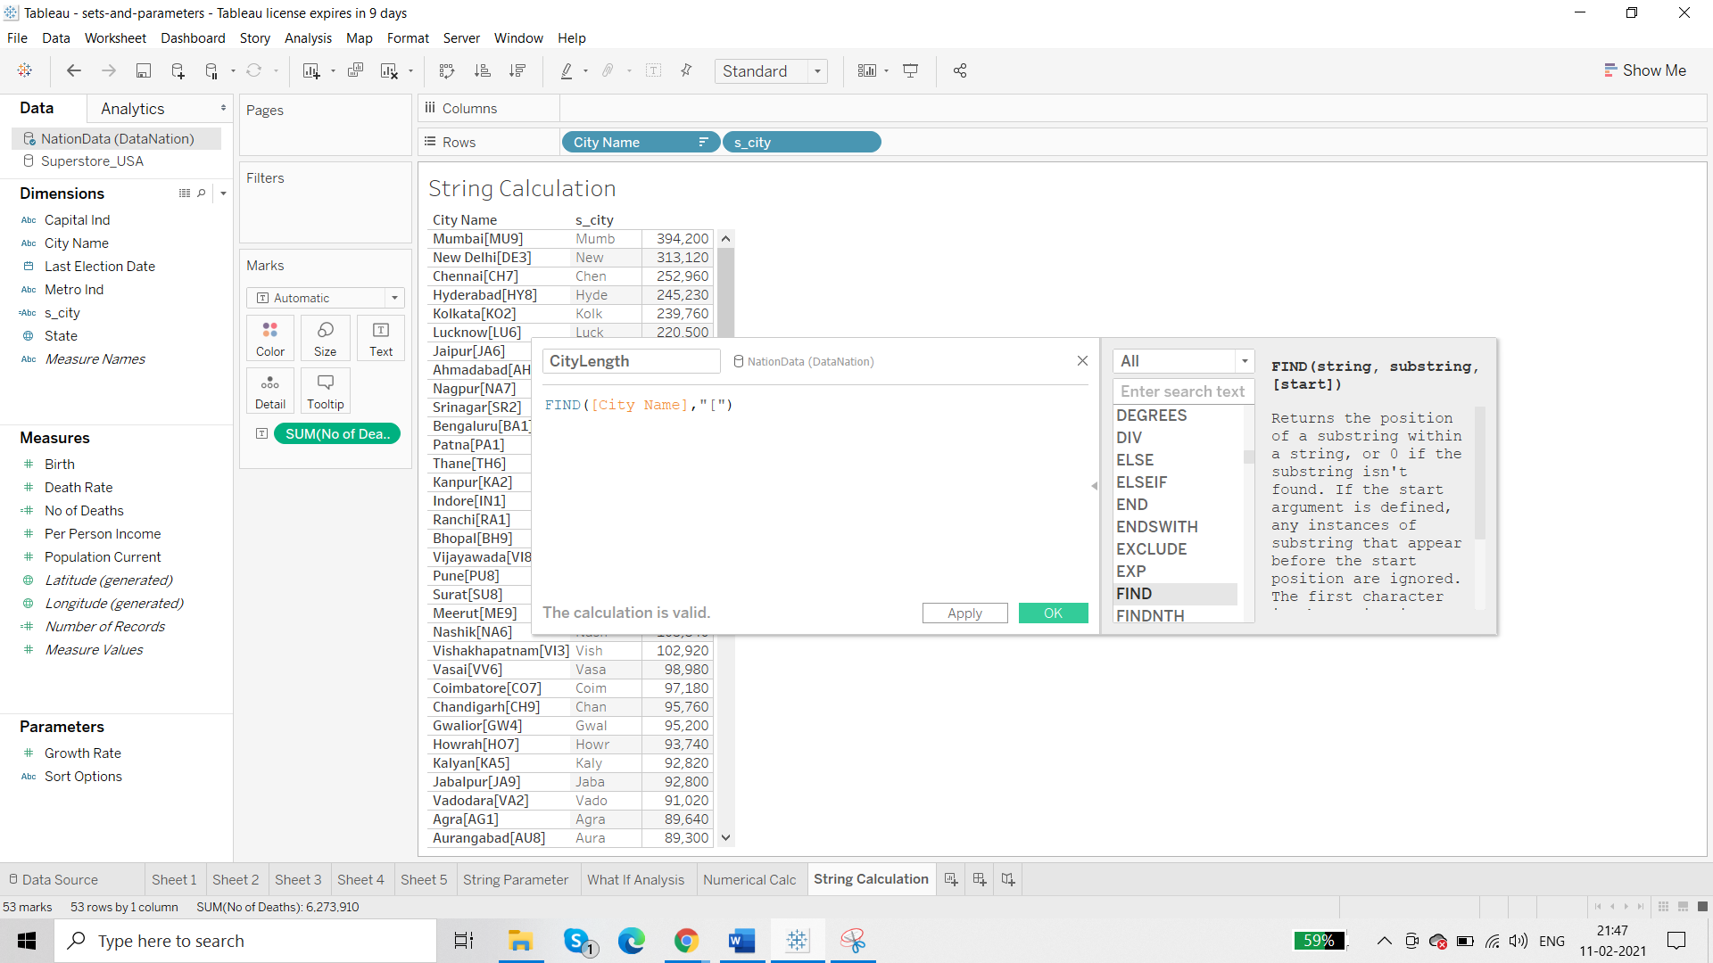

-1

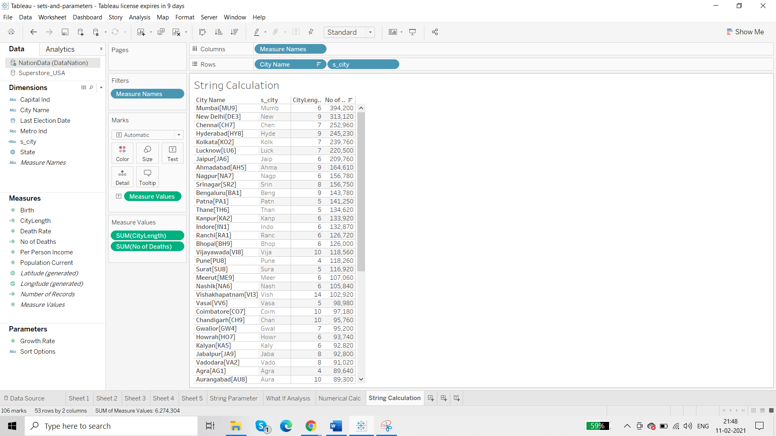

Edit s_city:

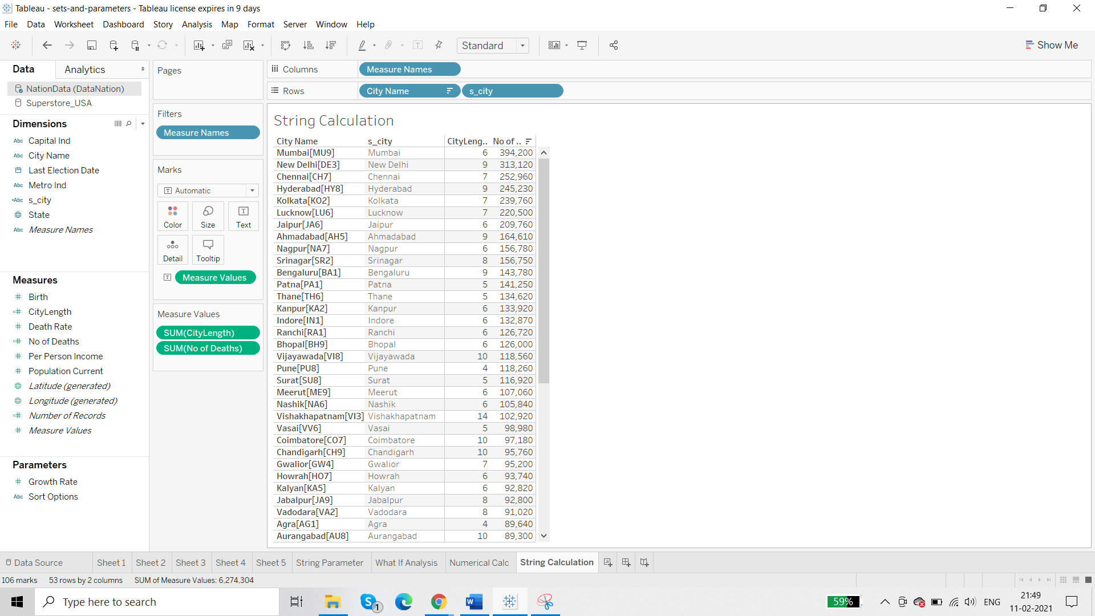

**Approach 2:**

Custom split cityname

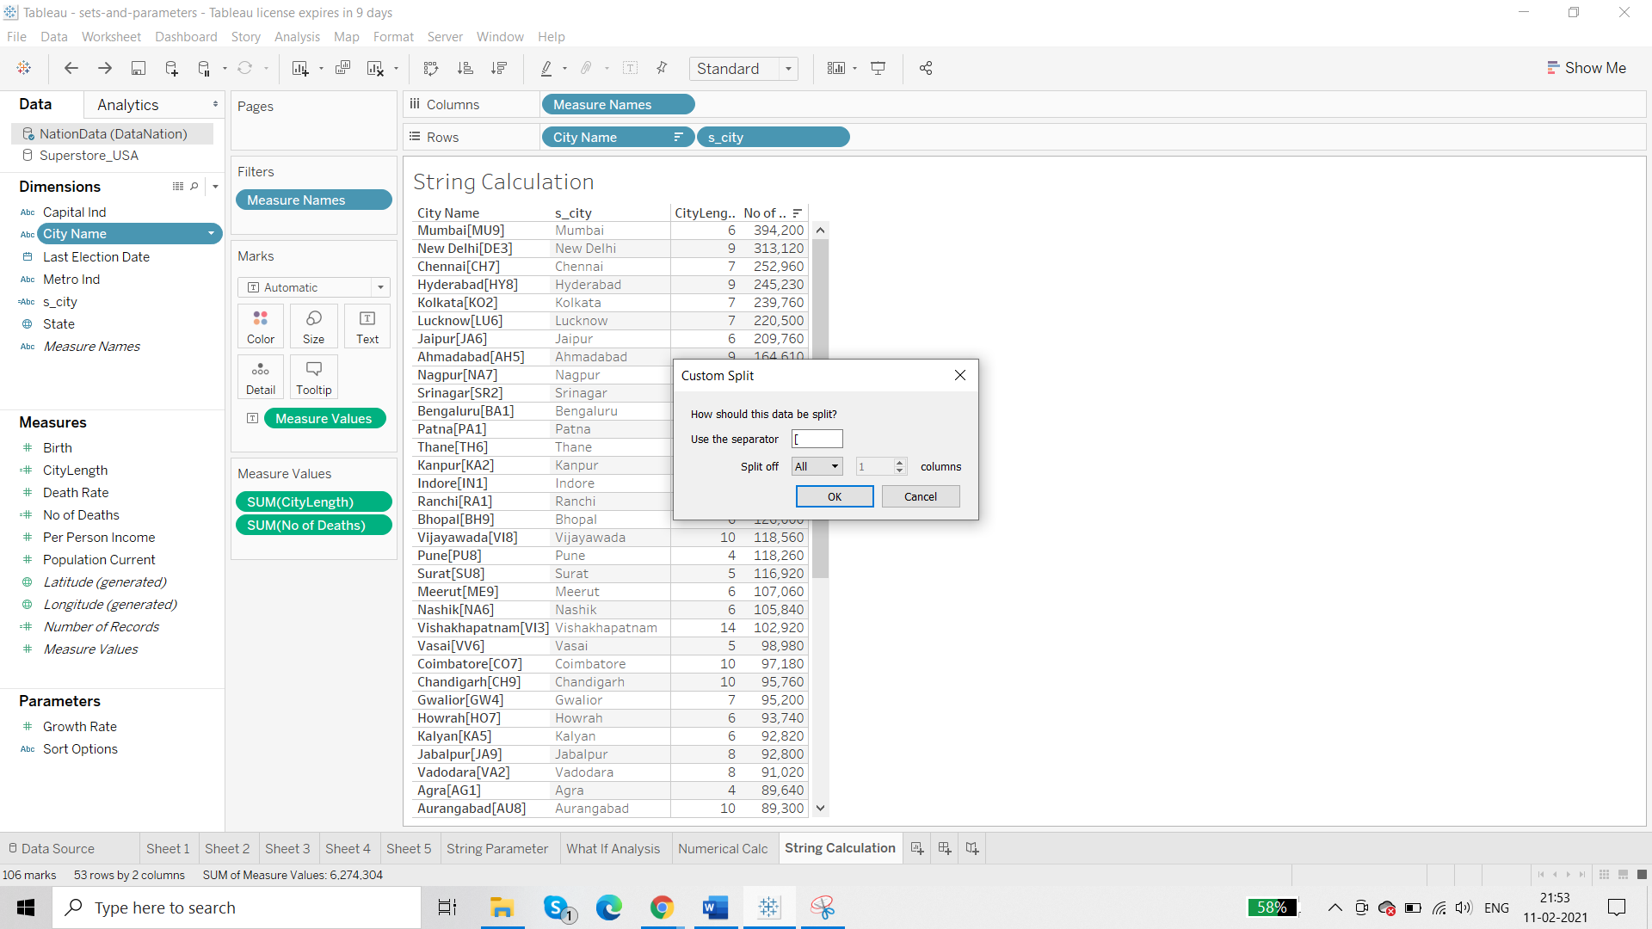

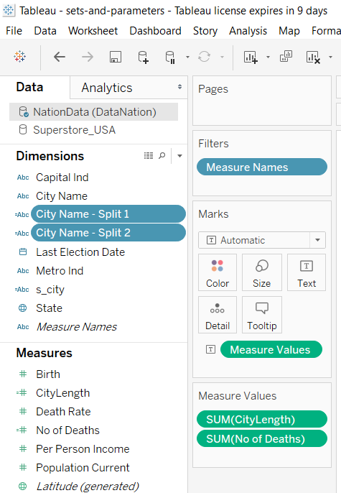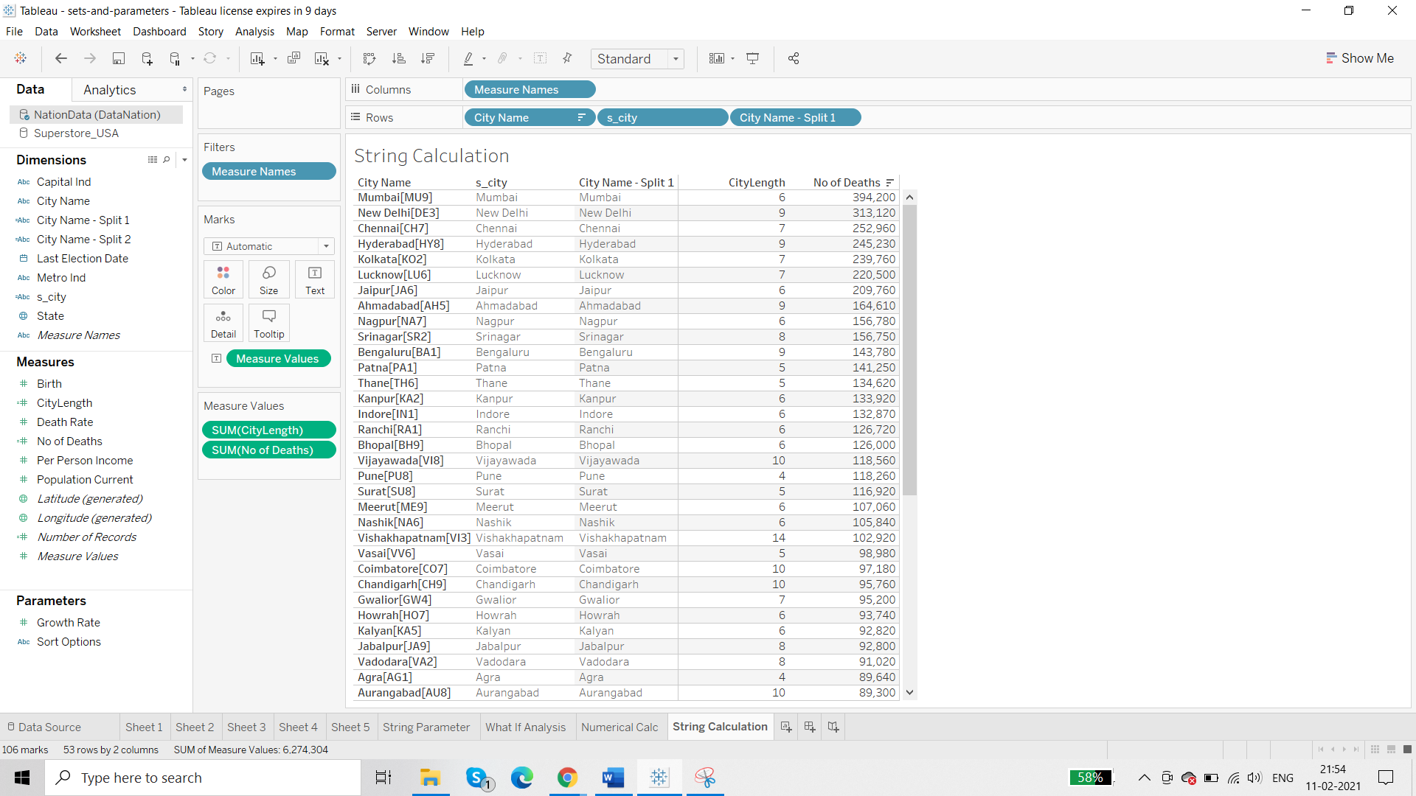

So this is correct

Rename the City Name Split 1 as Clean City Name